ecember 1999

Volume 45, Issue 11

ro

*

*

&

*:

*

*

* o

^ i>-

* o
* o
* i
* ~J (VI
* 3ET -43
* o m
* o ^ O-Om
* jEzr-
* «coc

^UKC3 *< «3r

&ZC «c

*oc oz

aKCJiCOC *=LU „J ♦ CCOK

*cacu<i:

We wrap up 1999 with  
a bundle of great new things  
in Access Control products and technology

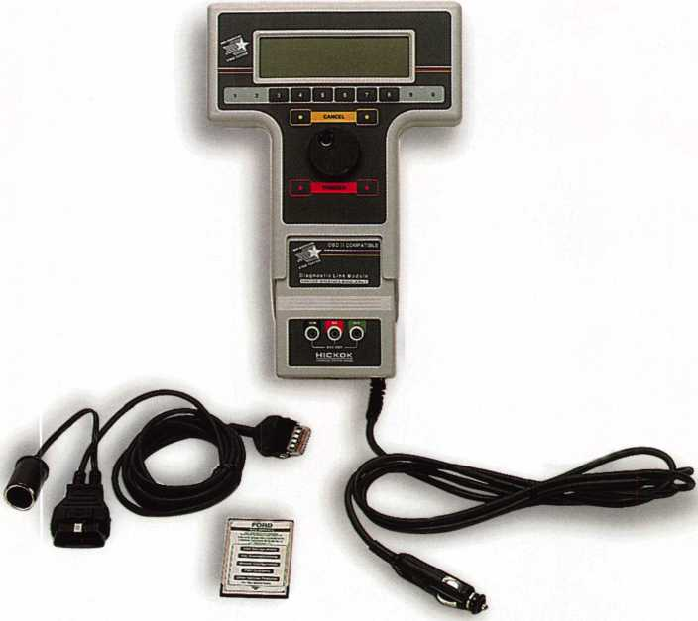

**HICKOK**

INCORPORATED

Contact Hickok Inc. at (800) 342-5080  
for more information on a distributor in your area.

**Your FULL. PATS programming**

TOOL IS NOW AVAILABLE!

**New Generation STAR (NGS) Tester**

(800-8LA)

* Use the NGS to program keys into Ford-Lincoln-Mercury vehicles (1996 to current model year 2000) equipped with a Passive Anti-Theft System (PATS).
* The NGS kit (Model 800-8LA) contains the components to access all vehicles equipped with PATS.
* Stop sending your customers to the competition, or to the dealer when you can provide the service, make money and save the customer time.

AIR

BAG

AIR

BAG

AIR



If you don’t want  
an air bag popping up  
all of a sudden and ruining  
your day, then this Guide  
from Mitchell is for you.

|  |  |
| --- | --- |
| Mitchell | & |
| AirBag  Quick |  |
| Refermce |  |
| Guide | d |
| 1999 Edition |  |
| Mitche// | m |

When you’re working around air bags, there is no substitute for the • Complete, easy-to-read “CAUTIONS” to prevent accidental

specific model’s most up-to-date air bag information. Accidental air bag deployments.

deployments are expensive and dangerous, and this is the Guide that • Specific Year, System, Model articles.

can save you from sudden disasters. This Air Bag Quick Reference • Air bag component location.

Guide from Mitchell features: • Special introductory price of $49.95* (regular price is $75.00)

To order or for more information, call

1 800 238-9111, ext. 4070

*Call today, because the special offer of $49.95 expires December 31,1999!

Mitche//

intents

Features

President’s Journey

By John J. Greenan, CML, CPS

llfinftmhfir

. » _

**Volume 45, Issue 11**

14

The Yellow Pages...The Ultimate Idea Source Locksmiths take note. One of the best ways of getting your name out to the public could be right next to your telephone.

Clint Pollard

15

Field of Dreams

Keynotes profiles this year’s ALOA Award winner, Peter Field, RL.

Mike Emery

16

jCincinnati Proximity

Our author evaluated SecuraKey’s new proximity access  
control system at ALOA ’99- Get the facts on its benefits  
and applications.

iPaul Chandler, CRL

120

hat was HID shall be found.

A top producer of electronic access control introduces  
the “eProx module.”

Paul Chandler, CRL

24

Strattec 2000, Part 2

A continuation of what to expect from Strattec next year.

Sal Dulcamara, CML

Good Things Come in Small Packages

Silent Witness. No, not the latest John Grisham thriller,  
but an innovator in CCTV. Read about its latest offering,  
the SWC40.

Paul Chandler, CRL

...jen Good Employees Go Bad  
Sometimes your best employees can be your business’  
worst enemies.

Tim McMullen

TTie Cover

What’s inside? Lots of new and interest­ing access control items. From proximity readers to CCTV, we wrap up 1999 with features on the latest products and newest technology!

31

Finding A Noble Niche

The father and son team of Meir and Gady Avganim are the brains behind Noble Enterprises. From gun locks to computer locks and more, this duo is turning heads with their innovative products.

Sal Dulcamara, CML

Art direction/design Valerie Rowe

32

The Woes of Inventory

Inventory. It’s a tough job but somebody’s gotta do it.

Here are some insights and hints that will help you prepare for the coming year.

Don Dennis, CPL

33

Suggestive Selling 101

No prerequisites for this class. Just quick thinking and  
a little imagination!

|  |  |
| --- | --- |
| | Keynotes | Claire Cohen, CML  December 1999 |
| r |  |

Departments

6

Core

Sensormatic goes to Greece, GPLA looks ahead

Upcoming Events

42

8

10

Security Marketplace

Authors in This Issue

44

Back Page

34

Classifieds

36

Associate Members

39

Ad Index

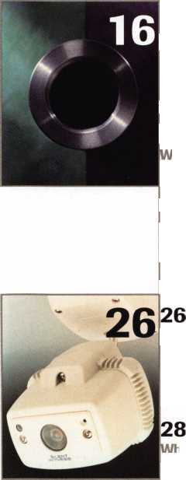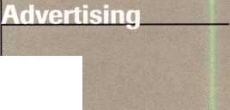

Communications/Financial Coordinator Editorial Advisor

Advertising Sales

Contributing Editors

Contributing Authors

[david@aloa.iofifice.com](mailto:david@aloa.iofifice.com)

Patanya Johnson

John D. Cannon, CML

[jdcannon@worldnet.att.net](mailto:jdcannon@worldnet.att.net)

Marvin Diamond

Native American Journal Co.

(706) 782-0878

[thediamonds@mindspring.com](mailto:thediamonds@mindspring.com)

Paul Chandler, CRL

Claire Cohen, CML

Sal Dulcamara, CML

Jerome V. Andrews, CML

Brian Costley, CML, CMS

Bob De Weese, CPL

Ray D’Adamo, CML

Michael A. Ferrill

James Glazier, CML

Daniel Graflfeo, CRL, CMS

Wayne Gurnee, CRL

A.J. Hoffman, CML

Ken Holmlund, CRL

Ray Lusk, CML

Mark Ohno

Randy Simpson, CML

Robert Stafford, CPL

Dave Thielen, CML

Additional contact information for the ALOA Board and most Keynotes authors is available through “Locksmith Search”’ on the ALOA website- [www.aloa.org](http://www.aloa.org) or by contacting the ALOA office at 3003 Live Oak Street; Dallas, TX 75204; (800)532-2562; FAX (214)827-1810; e-mail [aloa@aloa.org](mailto:aloa@aloa.org).

President

John J. Greenan, CML, CPS (773) 486-2030

Secretary

John D. Cannon, CML (703) 960-6413

Directors, North Central

Mark E. Blum, CML, CPS (517) 482-5809 Tom Ripp, CRL

1. 262-3831

Directors, Northeast

James H. Glazier, CML (301) 831-5454 John C. Magee, III

1. 845-3434 William L. Young, CML
2. ) 647-5042

Director, Northwest

Scott L. Henke, CRL, CPS (907) 248-3785

Director, South Central

Randy L. Simpson, CML (713) 780-7026

ALOA Professional Staff

|  |  |  |
| --- | --- | --- |
| Executive Director | Charles W. Gibson, Jr., CAE [charlie@aloa.ioffice.com](mailto:charlie@aloa.ioffice.com) |  |
| Operations Manager | Mary May  [mary@aloa.ioffice.com](mailto:mary@aloa.ioffice.com) |  |
| Comptroller | Kathy J. Romo |  |
| Meetings Manager | Jessica Smith [jessica@aloa.ioffice.com](mailto:jessica@aloa.ioffice.com) |  |
| Government Affairs Manager | Tim McMullen [tim@aloa.ioffice.com](mailto:tim@aloa.ioffice.com) |  |
| PRP/Education Manager | David Lowell, CML, CMS [david@aloa.ioffice.com](mailto:david@aloa.ioffice.com) |  |
| PRP/Education Coordinator | Ashley Spencer |  |
| Chapters & Regional |  |  |
| Associations Liaison | Tim McMullen [tim@aloa.ioffice.com](mailto:tim@aloa.ioffice.com) |  |
| Information Systems Manager | Randy McChristian |  |
| Mailroom Assistant | Mike Harrison |  |
| Receptionist | Barbara Ortiz |  |
|  |  | w |

Mission Statement: The Associated Locksmiths of America, Inc. is dedicated to enhancing the professionalism, education and ethics among locksmiths and those in related sectors of the physical security industry. With approximately 10,000 members in the United States, Canada and the freeworld, ALOA is poised to help members obtain the knowledge, the strength, and the confidence to perform their role in the physical security field with pride and dignity. But it is only through active involvement and participation that ALOA can fully achieve its potential-and can help members to achieve theirs.

Policies: Keynotes? is the official publication of the Associated Locksmiths of America, Inc. (ALOA). Keynoted acts as a moderator without approving, disapproving, or guaranteeing the validity or accuracy of any data, claim, or opinion appearing under a byline or obtained or quoted from an acknowledged source. The opinions expressed by the authors do not necessarily reflect the official views of ALOA. Also, appearance of advertisements and new products or service information does not constitute an endorsement of products or services featured by the Association. The Association does not accept responsibility for the inaccuracy of any data, claim, or opinion appearing in this publication, due to typographical errors on the part of the authors, Association staff or its agents. Editor’s Note: This publication is designed to provide accurate and authoritative information in regard to the subject matter covered. It is provided and disseminated with the understanding that the publisher is not engaged in rendering legal or other professional services. If legal advice and other expert assistance is required, the services of a competent professional should be sought.

Authors’ Payment: Payment for eligible submissions to Keynotes will be based on the following criteria: topic, time spent and past contributions. Authors who regularly submit to Keynotes are generally paid a higher rate. The latter is especially true of authors who write to fit specific editorial needs and submit said copy by Keynotes deadlines. As a general guideline: Average payment for a 750 word, business or ‘light’ technical article would be $200. Payment for a 1500 word article involving significantly higher time and research efforts would be $400.

Payment will not be offered for articles submitted by ALOA employees or members of the ALOA Board of Directors (unless material is of a technical nature), nor for articles submitted by a company that promote that company’s products or services. ALOA reserves the right not to pay for articles submitted by an individuals) that promote a particular company’s products or services.

Disclaimer: The Associated Locksmiths of America, Inc., (ALOA), reserves the right to refuse any article for any reason. Additionally, ALOA reserves the right to edit amend or modify any article submitted for publication in order to preserve technical accuracy, clarity, fairness or grammatical correctness. ALOA will make the best efforts to notify the author of any changes. The extent of ALOA’s liability for any article or information contained therein will be a notice of correction or retraction in the next possible issue.

Keynote^ (ISSN 0277 0792) is published monthly except for the combined June/July issue by The Associated Locksmiths of America, Inc., 3003 Live Oak St., Dallas, TX 75204-6186. Telephone: (214) 827-1701; FAX (214) 827-1810; e-mail [aloa@aloa.org](mailto:aloa@aloa.org). Subscription rates for members-$15.00 per year. Second class postage paid at Dallas, Texas. POSTMASTER: Send address changes to: Keynotes, 3003 Live Oak St., Dallas, TX 75204-6186. © Copyright 1999, All rights reserved. No part of the contents may be reproduced or reprinted in any form without prior written permission of the publisher.

Directors, Southeast

Thomas W. Tate (850) 476-4211 Donald E. Rule. CML (601) 324-2658

Directors, Southwest

Gordon R. Racine, CML (719) 384-4707 John A. Ilk CRL (602) 420-2174

Director, Associate Members

Judd Penske (800) 634-5465

Trustees

Dallas Brooks

(334) 826-8990

David M. Lowell, CML, CMS

(800) 532-2562

BreckH. Camp, CML

(770) 455-6244

Edwin Toepfer, RL

(416) 225-5589

Past Presidents

1997-1999 Dallas C. Brooks 1995-1997 David Lowell, CML, CMS 1993-1995 Breck Camp, CML 1991-1993 Henry Printz, CML 1989-1991 Evelyn Wersonick CML, CPS 1987-1989 Leonard Passarello, CPL 1985-1987 Joe Jackman, CML 1983-1985 Stanley Haney, CPL 1981-1983 Louis LaGreco, CPL 1979-1981 John Kerr, RL 1977-1979 Clifford Cox, CML 1974-1977 Charles Hetherington 1972-1974 Gene Laughridge 1970-1972 William Dutcher, RL 1968-1970 Constant Maffrey, RL 1966-1968 Harold Edelstein, RL 1964-1966 William Meacham 1962-1964 Robert Rackliffe, CPL 1960-1962 Edwin Toepfer, RL 1956-1960 Ernest Johannesen

December 1999

Keynotes il

with John J. Greenan

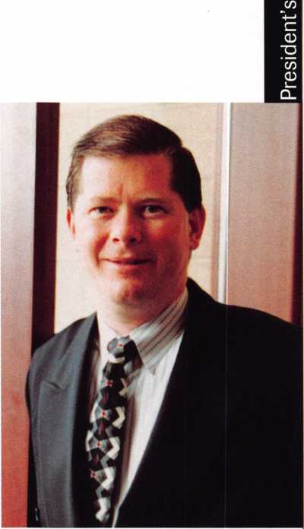

It’s certainly been a busy month! In the past month or so, I’ve had the opportunity to attend numerous conventions and tradeshows. In addition to that, the ALOA Board held its Fall Meeting at the Yankee Convention in Sturbrudge, Mass.

It never fails. Just as the holidays approach, there is so much to see and do, not to mention holiday shopping. Nonetheless, I made it to the following shows: National Burglar and Fire Alarm Association, Fox Valley Chapter and Master Locksmiths Association in London.

All events were certainly informative and I was able to meet a lot of people in our industry to exchange ideas.

Likewise, the recent Board Meeting proved to be very productive as well.

Among the points of discussion was the criteria for appointing Life Membership.

As many of you are well aware, ALOA awards Life Membership to past Board members as well as those professionals who have made outstanding contributions to the association and the industry.

To help determine the criteria for achieving Life Membership, we appointed a committee, which will provide recommendations for selecting these individuals.

In all, a solid meeting with plenty of input and ideas from your ALOA Board.

As the holiday season is upon us, I hope that all of you are able to spend time with those who matter most. Likewise, I hope that all of you travel safely and make the most of this time of year.

Its hard to believe that the 20th century is coming to a close. Of course, most of us will be a little nostalgic as we enter the year 2000, but as an association, we must look towards the future. New technology. New Faces. And of course, ALOA 2000 in Las Vegas!

It’s been a great year for ALOA and a great decade. Let’s keep up the good work.

See you in 2000!

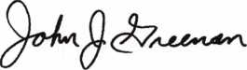

John J. Greenan, CML, CPS

December 1999

**iL** Keynotes

175 101 93 _ 66_ 65_ 64 . 62 _ 51_ 48_ 40 _ 38 _ 37_ 33 _ 32 _ 31_ **31_** 30 _ 29 _ 26 _ 24 _ 24 _ 24_ 24 _ 24_ 23 _ 23_ 23 _ 22 _ **21_** 21 _ 21 _ 21 _ 21 _ 20_ 19 _ 18 _ 18_ 18_ 18_ 18_ 17 _ 17 _ **17_** 17 _ 16_ 16_ 16 _ 16 _ 16 _ 15 _



Kwok-kei Leung

Toshihiro Asano

Henry Raymond

Stewart Levine, CML

Charles Robertson, CML

Mary Ohmit, CPL

Yuriko Yanai

Jack Hobin, CPL

Allen Konrath

.Salvatore Dulcamaro, CML

Myeong-Rae Cho

.William Neff, CML

David Lowell, CML

Thomas Freehling, CML

Dana Barnum, CML

John Heckman, CML

Jeanne Lodge, CML

Barry Leas, CRL

J Thomas Hood, CML

Danny Rudd, CPL

John Elliott, CML

Larry Warnick, CML

Roy Renderer, CML

.Jim Williams, CRL

James Watt, CML

Robert Carroll, CPL

Robert DeWeese, CPL

Diana Barnum, CRL

Anthony Ramunno, CML

Jerome Cohen, CML

.David M A Federico

_Eugene Altobella

William Lee

Elvis Hammerschmidt, CPL

Marian Swann, CRL

John Shandy, CML

.John Dorsey, CML

D Michael Lee, CPL

James Fowler, CML

David Harris, CML

John Kerr, RL

Keizo Takahashi, CRL

Ronald Heidzig

Philip Rovenolt, CPL

Lawrence Smith, CML

Joseph Ferrero, CML

James Cawby, CML

Michael Robinson, CRL

Brian Reetz

Walter Lascar, RL

Best.

The Brightest And The

.Thomas Vandersteen, CMC? .William Grant, CRL .Gary Teams, CPL .William McElheney, CML

Robert Duman, CML

Russell Fuller, CRL

Rex Parmelee, RL

James Gruber, CRL

James Brickler, CRL

Michael Groves

Daniel Landry

Edwin W Scott

Peter Gauthier, CPL

Frank Hartung, CML

Jon Griswold, CML

Paul Souber

Richard Sievers

Joe Lee, CRL

Steven Spiwak, CRL

_Robert Rodocker, CRL .Keiryu Tsukishiro, CRL Rolando Bouza

.Lonnie McKinney, CML

John Engel, CRL

Donald Shiles

Eric Veal

.Herbert Dusenberry, CML

Raymond Lusk, CML

Dale Knowles, CPL

Robin Horsley

.Thomas Demont, CML Ernest Wright

.William Wickward, CML Lester Brodsky

.Joseph Whitaker, CPL James Hawley, CRL

How can I join the President's Club?

You can earn membership in this prestigious club by recruiting just 10 new members for ALOA.

*Any ALOA member may participate.

What do I get?

When you recruit 10 members, you receive a handsome blue blazer with a President's Club crest. For each additional five members you recruit, you receive a lapel pin with gold-filled numbers, indicating your recruiting successes.

You also get the satisfaction of knowing that you are helping your association, helping your industry grow, and you are helping fellow locksmiths achieve success.

How do I get started?

Contact the ALOA office for a supply of applications (800) 532-ALOA or FAX (214) 827-1810. One President's Club credit is awarded for each new applicant. Credit is awarded only after the membership application is approved. However, the credit will apply for the period in which the application is received. Failure to identify yourself as the sponsor on the application form at the time it is submitted to ALOA for processing will forfeit any credit.

*AL0A Board of Directors not eligible for membership in the President's Club.

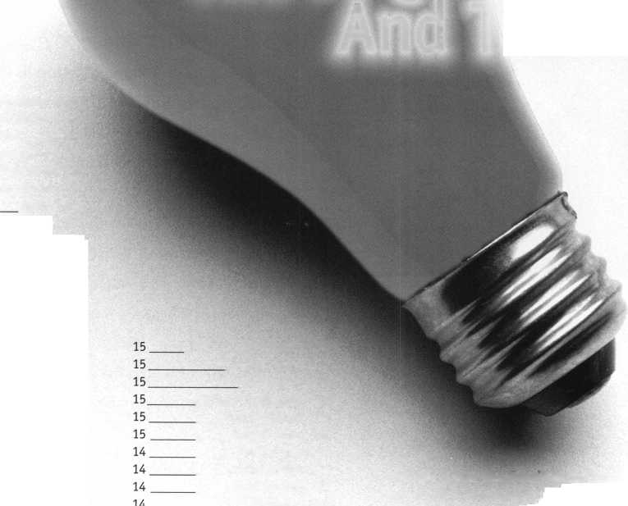

core



• Sensormatic at Playboy Casino

All eyes are on the Playboy Casino in Rhodes, Greece. Now that Sensormatic’s CCTV and access control

has been installed (by Sirio, Casino Systems Integrator), the facility will be under the watchful vision of various electronic security products.

The hotel/casino overlooks the Aegean Sea and is located in a renovated building with 37 luxury suites, a full casino and two restaurants. Among the Sensormatic products installed are SpeedDome Ultra Cameras, fixed cameras, and Software House C«CURE 800 security management system. Also included are an American Dynamics MegaPower 2050 matrix switcher and an audio surveillance system custom designed by Sirio.

• GPLA Looks toward the future

Hurricane Floyd forced the cancellation of the Greater Philadelphia Locksmiths Association’s 50th Jubilee Exhibit and Banquet, but the association is remaining optimistic about next year’s event. GPLA’s 50th Plus One Convention and Awards Banquet will be held September 13-18. In a recent press release from GPLA, President Robert Mock stated, “Floyd may have dampened our feet, but not our spirit.”

Keynotes

December 1999

(From Left: Don Decker, CML, CPS of the Ohio Valley Chapter of ALOA; Robert Turner of OB FA A and POLA; Bill Mandlebaum, CPL ofPOLA; Bill Lockwood, CRL of the Ohio Valley Chapter of ALOA; Ronald Betschman, CML, Chairman of the North Coast Chapter of ALOA; Tim McMullen of ALOA. Not Pictured: Mike Rumage, CRL, Chairman of the Ohio Valley Chapter of ALOA.)

• Legislative News

Recently, locksmith groups in Ohio sat down with the Ohio Burglar and Fire Alarm Association to work out an alarm licensing bill. The meeting was held on October 23 in Columbus, Ohio. In attendance were representatives from the North Coast Chapter of ALOA, the Ohio Valley Chapter of ALOA, the Pennsylvania-Ohio Locksmith Associa­tion (POLA), the OBFAA and ALOA. Currently, ALOA is working with OBFAA to allow locksmiths to do access control without having to obtain alarm licensing. Look in next month’s issue of Keynotes for even more information on this meeting and the bill.

Skip Bladen, Ostego, MI Bruce D. Colgate, Suffield, CT Robert D. Lamothe, Belchertown, MA Alan O’Daniel, Carrollton, TX Norman Schulthesis, St. Louis, MO Clayton L. Smith, Astoria, OR Karl Walker, Vernon Hills, IL David Hallee, Waterville, ME

ALOA is offering PRP/STPRP testing once a month at the ALOA Headquarters, every second Friday of the month, with the exception of February.

• Regions

This month the Greater Philadelphia Locksmiths Association holds its Holiday Party on December 10 in Pennsauken, NJ. For more details, call Martin Arnold at (856) 665-0464 or Bob Schuetrumpf at (856) 486-9280.

Would you like to see your regional association or chapter event listed? Just mail your complete information including date, place, contact name and phone number to:

Keynotes

3003 Live Oak Street Dallas, TX 73204 or fax to:

(214) 827-1810.

• PRP

CML

Alvin Ostheimer, Sandusky, OH

CRL

Kevin Ahrens, Lake Zurich, IL

INTERCHANGEABLE CORE PRODUCTS

**CONTROL**

KSP

Interchangeable

with:

•BEST

* ARROW
* FALCON

Quality • Price  
Delivery

That's what KSP is all about!

Ask your wholesaler about  
our drop shipping.

KILLEEN SECURITY  
PRODUCTS

***33 Hermon St.  
Worcester, MA 01610  
Phone (508) 798-3200  
Fax (508) 753-2183***

December 1999

Keynotes

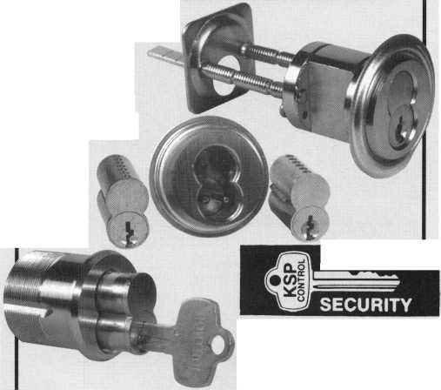

Upcoming

Events

Dept

DECEMBER

5

ALOA PRP Sitting Dayton, OH Ohio Valley Chapter Contact: Bill Lockwood (937)836-6127 (937)775-3736

11

**+** ALOA PRP Sitting Dallas, TX ALOA

Contact: David Lowell, CML, CPS (800)532-2562 (214) 827-1810 fax

2000

JANUARY

8

Ace Classes

Wyoming Locksmith Association Casper, WY

Contact: Gene Fieck, CPL (605) 642-4542 (605) 642-8946 fax

16

^ Ace Classes Nutmeg Chapter of ALOA Middletown, CT Contact: Bob Stafford, CPL (860) 768-7917 (860) 768-7801 fax

15

Investigative Locksmithing II Class Richmond, VA

Virginia Locksmiths Association Contact: Troy Miller (804)977-5397

22

Investigative Locksmithing II Class Towson, MD

International Association of Investigative Lockmsiths Contact: Don Shiles (800) 598-9491 Lenny Podgorski (410) 515-2934

|  |  |
| --- | --- |
| FEBRUARY | 2001 |
| 9-13 | MARCH |
| TLA Annual Convention and Trade Show | 28-April 1 |
| PRP Sitting | MLANJ 2001 Annual Convention |
| Houston, TX | Somerset, NJ |
| The Texas Locksmiths Association | (973)267-8884 |
| Contact: | (973) 538-2248 fax |
| Registration info: Jim Hetciller | [www.mlanj.org](http://www.mlanj.org) |
| (830) 606-1727 |  |
| Exhibitor info: Robert Hernandez | JULY |
| (210)433-5397 | 16-22 |
| General info: (877) TLA-INFO |
| ALOA 2001 Security Expo |
|  | Baltimore, MD |
| MARCH | (800)532-2562 |
| 17-19 | |
| Trade Show & Security Conference | 2002 |
| Troy, MI | JULY |
| IDN Hardware Sales, Inc | 22-28 |
| Contact: Fred Strasberger or Bonnie Weston | ALOA 2002 Security Expo |
| (800) 521-0955 | Rosemont, IL |
| APRIL | (800) 532-2562 |
| 6-9 | |
| MLANJ Annual Convention vtr- Ace Classes |  |
|  |
| Master Locksmith Association of New Jersey | \ ^ Indicates ALOA ACE Class  Indicates PRP Sitting |
| Somerset, NJ |
| (973) 267-8884 (973) 538-2248 fax |  |
|  |



MLANJ 2000 Annual Convention

April 6th thru April 9th Somerset, New Jersey

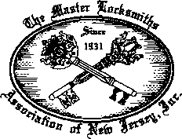

For More Information:

PO Box 2441, Morristown, NJ 07962-2441 Phone 973-267-8884 Fax 973-538-2248

Or visit our web site at[www.MLANJ.org](http://www.MLANJ.org)

***Keynotes***

December 1999



When she wanted to swim

an ocean

and an introduction to Shamu! Thanks

Make-A-Wish Foundation

1-800-722-WISH

www. makeawi$h .org

ick, there s nothing like the power or a wish.

If you know a child with a life-threatening illness, please call us.

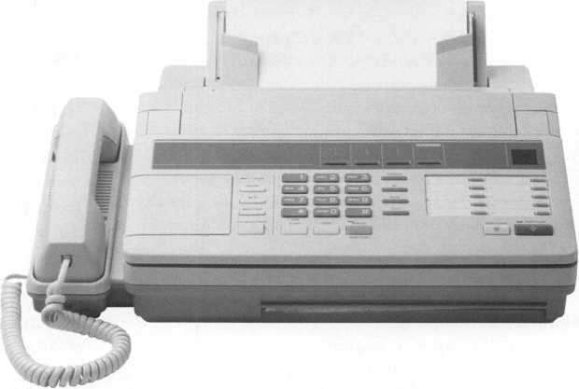

ALOA  
HAS  
FAX ON  
DEMAND!

Need information in a hurry?

Just call 310.575.5074 and you will be taxed:

Your association continues to explore ways to provide you, our members, with new benefits and services.

#1

#2

#3

#4

#5

#6

#7

#8

#9

#10

#11

#12

#13

#14

#15

#16

#17

#18

A list of all documents available through this service

Becoming A Locksmith  
Locksmith Career Summary  
Locksmith School List  
ACE Class Schedule  
Certification Information  
PRP Category List  
ALOA Membership Application  
ALOA List of Benefits  
Scholarship Application Form  
ALOA Video Library Order Form  
ALOA Membership Items Order Form  
Safe & Vault Technicians Association  
Member Application/Subscription Form  
ALOA Chapter Roster  
Legislative Action Network  
Legislative Action Network Newsletters  
Various State Laws  
Industry Position Paper

December 1999

Keynotes



**Security**

Marketplace

Sensormatic

Sensormatic Electronics Corporation introduces Integra, a digital time-lapse video recorder. Integra combines video processing with DVD-RAM disk technology. The removable optical disk size reduces archive library space. Integra installs and operates like a VCR. Other Integra features include no image distortion on freeze or fast playback, linear or continuous record mode, user selectable settings for image rates, quality and resolution and efficient recording format.

Sensormatic

951 YamatoRoad

P.O. Box 310700

Boca Raton, FL 33431-0700

(561) 989-7000

unvw.sensormatic.com

Videx

Videx introduces the TouchAccess lock for use with the Multi- Lock security bar manufactured by Harpers. The Multi-Lock security bar latches in front of file cabinet drawers, preventing them from being opened. With TouchAccess installed a user must first touch their “key” to the lock before the security bar is released. The TouchAccess lock records the user information and once the TouchAccess lock is opened the Multi-Lock can be released and the user has access to the files. This system has the ability to download an audit trail of the latest entries, with the specific date and time of each occurrence. Muti-Locks are available for two, three, four and five drawer file cabinets.

Videx

(541) 758-0521 (541) 752-5285 fax [sales@videx.com](mailto:sales@videx.com) tmvw.videx.com

NAPCO

NAPCO Security Systems has launched three alarm control panels, FW-C4Z, FW-C4EZ and FW-C2Z. These are 24V conven­tional fire alarm control panels that have dipswitch programming and selectable mult-tone output capability and are easy to install.

The unique features of each panel are: FW-C2Z- 2 Class B Zones, 1 Class A Zones and 2 Class A/B Zones and yields 2.75 Amps power. FW-C4Z- 4 Class B Zones, 2 Class A Zones and 2 Class A/B Zones and yields 2.75 Amps power. FW-C4EZ Expandable Panel- expandable up to 8 Class B or 4 Class A Zones by using the Firewolf 4-Zone Expansion Module (FW-EZM4) and boasts 5 Amps power. **NAPCO**

(800) 645-9445 Ext. 64

Adrian Steel Company

Adrian Steel Company, a manufacturer of commercial van and pickup equipment, introduces improved Grip-Lock ladder racks for full size and mini vans. The improvement allows many styles and



lengths of ladders to be transported on the same rack in different combinations. A new seven foot span between cross supports improves support for multiple ladder sizes. An optional stepladder kit provides support between the front and rear cross supports for shorter ladders. For longer ladders, a new extension kit adds two feet onto the front of the rack for additional roof protection and ladder support.

Adrian Steel (800) 677-2726 [www.adriansteel.com](http://www.adriansteel.com)

Corbin Russwin

Corbin Russwin has introduced The Vineyard Collection, a series of designer levers, roses and escutcheons. The Vineyard Collection consists of four lever designs, Merlot, Frascati, Zinfandel and Tuscany that combine contemporary and traditional elements into a look that lasts and blends with its surroundings. The Vineyard Collection was designed to help architects, builders and designers meet the high security needs of high-profile commercial buildings that use the Corbin Russwin ML2000 Series Mortise Lockset. **Corbin Russwin [www.yalesecurity.com](http://www.yalesecurity.com)**

Audio Video Supply

Audio Video Supply, a manufacturer and supplier of a large selection of audio and video equipment has launched a new web site, <http://www.avsupply.com>. This site offers a wide assortment of products varying from video security systems to professional broadcast cameras. Benefits of the site include: enhanced color photos and graphics; quick-loading, user friendly screens; credit card encryption; ability to view color pictures of products and more.

Audio Video Supply (800) 284-2288 [www.avsupply.com](http://www.avsupply.com)

SDC

Security Door Controls introduces SDC ZA7300 , an electrically operated Grade 1 extra heavy duty unit lock, designed to retrofit existing installations with Corbin/Russwin, Yale and Falcon mechanical unit locks. Features include a 4” square rose, vandal resistant pressure release lever, lever power return spring, choice of lever style and low current draw. The SDC ZA7300 may be ordered with another manufacturers keyway, or prepared to accept another manufacturers standard key cylinder or interchangeable core. A REX output is optional for access control applications.

Security Door Controls

3580 Willow Lane

Westlake Village, CA 91361-4921

(805) 494-0622

tvtvw.sdcsecurity.com

***Keynotes***

December 1999

Aegis Products Inc.

Aegis recently introduces Securedoor, an instant-egress, fire-rated 13-point locking security door that allows exit doors to remain locked during business hours, increasing security while meeting building, fire and safety codes. Securedoor has a multi-point locking system and an attack-resistant construction. ivww. securedoor. net

Secura Key

Secura Key announces the SK-ACP Advanced Control Panel, a two door access control unit. The unit accepts readers that have a Wiegand output with almost any card technology. Each of the two doors controlled by the unit is independent of the other and is configured, programmed and viewed separately. Each has a separate node address. Each of the two doors being controlled has two programmable inputs which may be programmed to function as a door open, remote inactive, door monitor, tamper, arming circuit, door unlock or user defined input. Each of the doors controlled by the SK-ACP has two outputs. One output is the Relay that activates the door operating device. The other output is programmable to activate under one of may possible alarm conditions, time zone or card violations. As a stand alone, the unit may be programmed using a PC. Transaction information is stored by the unit and may be downloaded to a PC or printer. Over 100 SK-ACP units may be connected together to control over 200 passageways with SK-NET software.

Secura Key

(877) 868-2422 (toll free)

(818) 882-0020 wxvw. securakey. com

Olympus Lock, Inc.

Olympus Lock announces the release of Olympus 2000, an integrated cabinet handle and lock in one unit. The product is designed to work with Olmpus Lock’s line of patented pin tumbler door and drawer cabinet locks #100, #200, #500 and #600. The Olympus 2000 handles are available in 26D and US3 finishes and fit right-hand and left-hand doors and drawers. Dummy handles are also available for non-locking applications.

Olympus Lock (800) 525-0954

Alarm Lock

Alarm Lock Systems introduces an enhanced version of the Trilogy T2 electronic digital lock, the DL2800. The DL2800 is available in both waterproof and non-waterproof models, comes in four finishes and with either lever or knob handles. The DL2800 has all of the features of the DL2700 and DL2750 and adds these functions, increased number of user codes, faster programmable passage times, selected manager codes with Passage Mode Control, Auxiliary Relay Functions, audible and visual LED prompts.

Alarm Lock (800) ALA-LOCK.

Instrument Technology, Inc.

A compact and portable video camera system for viewing or inspecting into normally inaccessible areas is now available from Instrument Technology, Inc. The camera mounted on the end of a 15 ft., telescopic pole can be used to search buildings, ships, aircraft and vehicles for firearms, explosive devices, contraband for criminal suspects. The system is field operational with battery packs, portable monitor, IR illuminator and telescopic pole with camera. An optional heads-up display unit is also available.

Instrument Technology**,** Inc.

P.O. Box 381, 33 Airport Road Westfield, MA 01085 (413) 562-3606 (413) 568-9809

[iti@scopes.com](mailto:iti@scopes.com) www. scopes, com

START YOUR OWN RESIDENT LOCKSMITH SCHOOL

Let me show you how to make a  
substantial above-average income by  
training men and women to become  
professional locksmiths.

We offer Administrative, Marketing,  
and Instructional assistance to ensure  
your complete understanding of how  
to start and maintain a profitable  
"Hands-on Locksmith School.

Included with the information are  
comprehensive lesson plans and  
instructional video's that thoroughly  
detail every aspect of locksmith

training.

INVITE YOUR

GOLDEN GATE SCHOOL

LOCK TECHNOLOGY

San Pablo Ave., Dept. A

Oakland, CA 94608

Phone (510) 654-9425  
Fax (510) 654-9429

December 1999

Keynotes

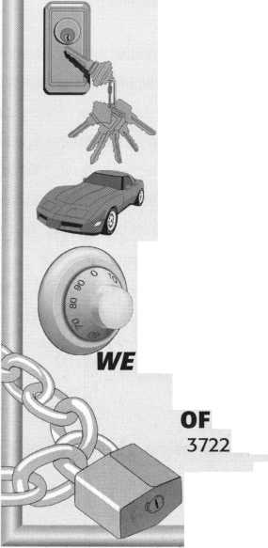

are plenty of investment choices out there. And it certainly can get confusing,

even when choosing liquid investments. So why not consider Series I Bonds? They’re  
backed by the U.S. Treasury, so every cent of your investment is protected. They’re  
guaranteed stay ahead of inflation for up to 30 years, and their interest is fully exempt  
from state and local income taxes. What’s more, you can get started with as little as $50.  
You can purchase them where you bank, work, or through the new U.S. Savings Bonds

EasySaver" Plan. To find out more, visit us

at **[www.savingsbonds.gov](http://www.savingsbonds.gov),** or write

to **I Bond Investor's Guide,** Parkersburg,

WV 26106-1328.1 Bonds. They’re one

easy, and safe choice to consider.

For more information about I Bonds, visit our website at [www.savingsbonds.gov](http://www.savingsbonds.gov)

A public service of this publication

Think About This



“If you want to study for the CPS test,

you need this book.

Without that book, I wouldn’t have my certification.”

-Dennis Johnson, CPS  
Aurora, Illinois

"Mike's new book is very  
consistent with the study  
information required to pass the  
SAVTA/ALOA CPS certification  
test. I wouldn't have passed  
without it. A tremendous  
resource for today  
and tomorrow..."

-John T. Grist; CML, CPS  
North Georgia Security

"The Safe Technicians Reference Manual by Mike Oehlert ranks among the best technical reference and learning aids you will find in the safe and vault industry. It contains page after page of essential information and easily understood illustrations. Besides answering most of the questions commonly asked by technicians new to the field, Mike has also included plenty of information experienced technicians will find useful."

-Ken Dunckel Pacifica, California

—►Over 600 Illustrations.-*—

320 pages. Only $135.

What are you waiting for?

To order, call 800-532-2562. Allow 3 weeks for delivery.

All major credit cards accepted; or make check payable to ALOA.

The Safe

Technicians  
Reference Manual

First Edition

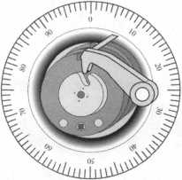

T

hey’ve been helping businesses grow for more than 100 years  
and are as essential to a company’s success as a fax or copy  
machine. They are, without a doubt, an indispensable part of

the marketing mix. And, when you don’t have a huge advertising  
budget, they are a necessity. They are The Yellow Pages.

But, today, The Yellow Pages are more than an age-old “must have” to grow your small business. They are an opportunity to position your locksmith business in a new, proactive and potentially profitable light.

Thanks to a groundbreaking $24 million national advertising campaign sponsored by The Yellow Pages Publishers Association,

The Yellow Pages will soon be top-of-mind for consumers everywhere.. .the very same consumers that are looking for locksmiths. The campaign features prime time TV spots and ads in major national magazines and newspapers and draws upon the notoriety of one of today’s most talented and talked-about stars,

Jon Lovitz, as its national spokesperson.

The focus of the campaign—“Me Yellow Pages'. Get An Idea”-is to drive consumers to businesses like yours. And, moreover, to reposition how consumers think about The Yellow Pages. The shift is revolutionary: no longer are directories simply convenient listings of

and address are crucial information to include in your The Yellow  
Pages ad. But, according to data conducted by Statistical Research,  
Inc., one in five consumers want more information in The Yellow Pages  
ads. The information they are looking for includes such things as  
store hours, detailed information about products and services,  
directions and maps, prices, years in business, payment options  
(such as credit cards and checks), and unique offerings and specials.  
Anything, in other words, that sets your business apart from the rest.  
For example, when looking for a locksmith, consumers may want to  
know if you specialize in certain types of locks, or they may want to  
know the specifics of the area you service to ensure you’re in their  
neighborhood.

OFFER TIPS AND ADVICE TO YOUR CUSTOMERS: Getting  
repeat and new customers through your door via your The Yellow  
Pages ad is encouraged by going that “extra mile” and giving them  
something more. Include advice, or tips, in your ads—for instance, if  
you specialize in dead bolts, provide statistics in your ad on how this

type of lock reduces  
the risk of break-ins.

HIGHLIGHT  
UNIQUE SERVICES  
AND PRODUCTS:

Design your The Yellow  
Pages ad so that it  
includes and calls

the yellow pages...

the ultimate idea source



by Clint Pollard

phone numbers and addresses. They are, in fact, a source of information and creativity, a place where consumers can turn to “Get An Idea! ”

One strategy of this aggressive campaign is to encourage adver­tisers like you to conceive of your Yellow Pages ads in different ways and to incorporate the “Get An Idea” concept. The campaign, because it will change the way consumers view and the frequency with which they refer to The Yellow Pages, means that locksmiths can position their businesses in ways that will help grow business and increase profits.

This can be done in a number of ways. Here are some ideas:

PUT IDEAS IN YOUR ADS: There’s more to a ad in The Yellow Pages than just simply phone numbers and addresses. Give your potential customers IDEAS. For instance, recommend that consumers buy a car lock deicer before winter begins to avoid being stranded in the cold.

ADVERTISE UNDER MULTIPLE HEADINGS: Research shows that when using The Yellow Pages, consumers often reference more than one heading. In fact, 21 percent of consumers reference at least two headings before finding what they want. Advertising your business in more than one place can dramatically increase the chances that someone will see your ad and contact your business. For example, aside from advertising under “Locks & Locksmiths,” you may also want to advertise under “Automobile Repairing & Service” for car lock emergencies or “Security Control Equipment & Systems” for home lock problems.

INCLUDE THE INFORMATION YOUR CONSUMERS WANT AND ARE LOOKING FOR: Naturally, your business’ phone number

A Keynotes December 1999

attention to the unique services and products your business provides. For instance, if you provide consultations or evaluations on the condition of a home’s locks, say so in your ad.

What does this mean to locksmiths? Currently, 35 million potential buyers consult the “Locks & Locksmiths” heading in The Yellow Pages each year, making it the 88th most-referenced heading (out of4,200). Considering that these impressive figures were achieved before the launch of a proactive The Yellow Pages industry initiative, imagine what can happen once consumers are inundated with The Yellow Pages message via this cutting edge national adver­tising campaign! And, imagine what can happen once you build upon the power of the campaign by incorporating the “Get An Idea” concept into your The Yellow Pages ads.

The Yellow Pages are a powerful and indispensable advertising medium. Consumers rank The Yellow Pages as the most informative method of advertising, ahead of television, radio, newspaper and direct mail. Indeed, you would be hard pressed to find a home or business in America that didn’t have one, if not several, well-used directories at the ready. With the average adult referring to The Yellow Pages approximately 1.8 times a week, and with almost 17 billion references made in The Yellow Pages every year, advertising in The Yellow Pages is clearly a must for any successful locksmith.

The Yellow Pages industry expects that the national advertising campaign and the repositioning of directories will have a profound impact on businesses like yours. Taking advantage of it by positioning your ad as “an idea source” is simple and profitable.

There's no doubt about it. Peter Field, RL  
loves locks.

This year's A.L.O.A. (ALOA Lifetime of  
Achievement) award winner has been  
tinkering with locks and similar devices  
since he was a kid. Now, as Research  
Director for Medeco, his days are  
dedicated to the company's latest products.

So, what does he like to do in his spare  
time?

"A lot of my spare time is spent with  
locks," he says. "I take them apart. I play  
with them. I study them. I do a lot of that in  
my basement. But I also do some elec-

tronics work, repairing two-  
way radios. That's fun. It  
takes my mind off of  
mechanics for a while and  
lets me concentrate on elec-  
tronics. That's a good change  
for me since I work with  
mechanical locks on a day to  
day basis."

Such enthusiasm has  
obviously factored into the 51  
year-old Field's professional  
success, but he also cites his  
friends and family as chief  
inspirations.

"My wife, Jane, is  
tremendous," he says. "It has  
been hard for her because in  
the last couple of years, I've  
had to be on the road a lot.

However, she has always  
been very supportive of my  
professional goals."

Another positive influence  
on Field was the man who  
presented him with the '99  
A.L.O.A. award in  
Cincinnati, Stan Haney.

Haney, a '97 A.L.O.A. award  
winner and former ALOA  
president once employed  
Field at Dave and Harry  
Locksmiths in Champaign, III.

According to Field, his warmth as an  
employer was instrumental to his profes-  
sional growth in the locksmith industry.

"Stan is a very remarkable man," says  
Field. "The employees who worked for him  
were treated like family. He really went out  
of his way to fit people to their jobs and  
help them train and grow. One of the  
things he encouraged me to do was to  
conduct training classes. At the time, the  
University of Illinois Police Training  
Academy needed help with Crime  
Prevention courses, and Stan motivated me

to give them a hand."

Field managed to squeeze in as much instructional work as possible in between his long hours as a Dave and Harry employee. But as much work as he was doing, he liked it, particularly teaching.

Fortunately, the added work as an instructor did not go unnoticed. Represen­tatives from Medeco had seen Field's training courses and decided that the company needed a similar class to teach locksmiths about Medeco cylinders. It wasn't long before Field left Dave and Harry and began working for Medeco,

where he's remained for over 20 years.

"It wasn't a large difference from what I was doing on a daily basis because I was still teaching," he says. "Of course, it meant that I did not have to service vehicles or run in and out on service calls all day. Working conditions changed but it was the same idea. The things I've done since I've been with Medeco haven't been major departures or changes. They've been more of an evolution."

Originally, a native of the Chicago- area, Field now resides in the picturesque

confines of Salem, West Virginia. He's  
been happily married to wife, Jane for 29  
years and has three sons, Brandon (age  
23), Graham (20) and Tyler (17).

Field says all of his sons have dabbled  
in locksmithing in some form or fashion. In  
fact, eldest son, Brandon has worked for a  
locksmith and even participated in a  
'foreign exchange' of sorts.

"At one time, a friend in Europe and I  
arranged an exchange program," says  
Field. "I had his son over here for a few  
months. He stayed at our house and  
worked at the office. And Brandon went

to Europe for the summer,  
working as a locksmith  
there."

Although he has fond  
memories of his time in  
Illinois, he has grown  
equally attached to the  
hilly landscape of West  
Virginia.

"We're in the Blue  
Ridge Mountain region,"  
he says. "So, we're not in  
the flat corn fields of  
Illinois. The biggest  
difference is that this  
area has a lot of clay,  
so there's a lot of red  
soil as opposed to the  
black soil that I was used  
to in Illinois."

As for the future, Field  
says he's looking forward  
to the advent of new and  
exciting products.  
Considering all of the  
technological changes  
the locksmith industry is  
seeing, he's intrigued at  
what the next few years  
have in store.

"I always have  
personal and profes-  
sional goals and work

towards them," he says. "I think there are  
some very interesting changes in the  
industry. That means the next couple of  
years will be more exciting than ever  
before. There's going to be faster growth,  
better products and perhaps better prices.  
All of these changes are important for the  
locksmith because almost every month  
there's something new. That's one of the  
things I love most about this line of work.

It's so diverse that there's something for everybody."

By Mike Emery

December 1999

Keynotes

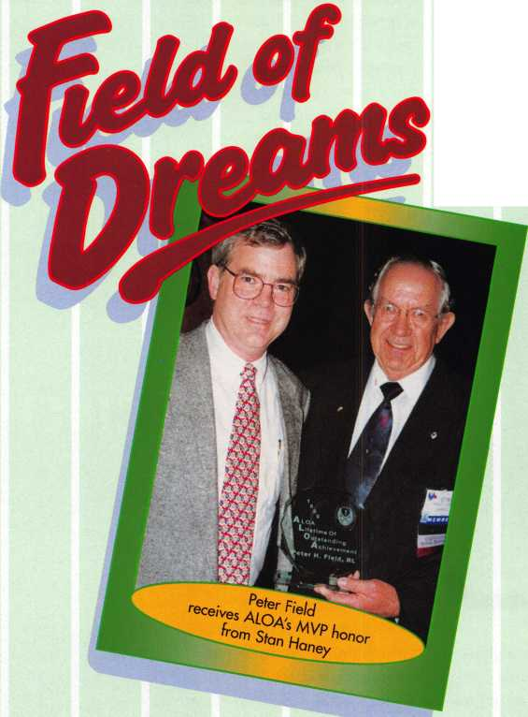

A s electronic products manager for a security hardware distributor, part of my job is evaluating new electric locks and access controls. In my free time, I also teach classes for ALOA and write product reviews for this magazine. Often times, these three jobs overlap.

For example, this summer I was sent a new proximity access control system from SecuraKey for a 30-day evaluation. At the time, I was preparing to conduct a two-day access control class in Cincinnati, which was to include a real-life installation of a two- door card reader system. I was so impressed with the new SecuraKey product that I asked their national sales manager, Eric Bernocco, to donate it to ALOA for our class. He was only too happy to oblige. This gave me the

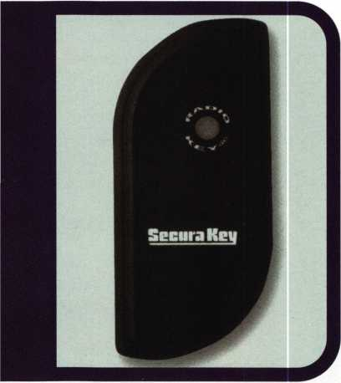

opportunity to put the system through its paces and to see whether it was really installer-friendly. It also gave me some great insights for a magazine article (this one).

SecuraKey has been a leading manufac­turer of access controls and cards for several years now, specializing in barium ferrite ‘TouchCard’ readers. Barium ferrite readers are among the most weather-resistant and rugged stand-alone access controls available. Nowadays though, proximity has become the card technology everyone loves. Prox cards are similar to the transponders in many new car keys. They are called proximity’ because they don’t have to actually touch the reader, merely be held close to (in proximity of) the reader. Often, this means you don’t have to fish the card out of your wallet or



Keynotes

December 1999

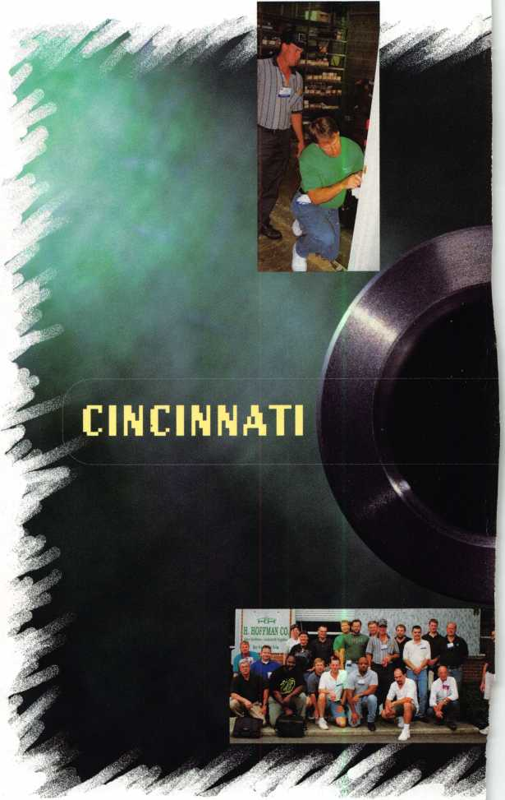

purse. In addition to convenience, this results  
in less wear and tear to both the card and the  
reader. Also, since the radio frequency  
between the reader and the card can pass  
through most materials, the prox reader can  
be concealed inside a wall or behind glass for  
extra protection.

The new products I received from

SecuraKey included  
two new proximity  
readers. The RK-WM  
(pictured on this page)  
is approximately 1 1/2"  
by 3 1/2", small  
enough to be mounted  
directly on a door frame  
or mullion. It can read  
cards as far as six inches  
away. The other reader  
was the RK-WS  
(pictured on page 17).

It is about the size of a  
light switch plate and  
has an eight inch range.

Both feature an  
exclusive technology  
called ‘Dynascan,’  
which tunes the radio  
transmission of the  
reader to the environ-  
ment where it is  
installed to achieve the  
best range in every  
application.

The RK-WM and  
RK-WS send data to a  
separate access  
controller. Since the  
lock control relay and  
other wiring are in the  
controller, not in the  
reader, a would-be  
intruder might tear the  
reader off the wall but  
he still can’t unlock the  
door. SecuraKey card  
readers can communi-  
cate to a controller in  
26 to 40-bit Wiegand

formats. The most popular communications  
protocol in the industry today is 26-bit  
Wiegand. This means that SecuraKey readers  
can be connected to access control systems  
from many different manufacturers.

SecuraKey produces both cards and key ring tags that can be used with their readers. The 1 1/4" by 2 1/4" key ring tags are

Panel”. The SK-ACP is a two door control unit that is connected to SecuraKey readers, or any other type of reader with a Wiegand output. Each ACP has two programmable inputs and two outputs per door. The inputs would typically be for a door status switch and a Request-To-Exit (REX) button. One of

somewhat more expensive than cards ($5.00 list versus $2.60) and have slightly less read range. Still, many people find the tag more convenient to carry than a wallet-sized card.

While the RK-WM and RK-WS can be used with controllers from other manufac­turers, SecuraKey would rather have you use their new SK-ACP “Advanced Control



connected by an RS232 serial cable and may  
be either permanently attached or you can  
simply plug in a laptop when you want to do  
programming. A dedicated computer is not  
required. The SK-ACP network has all the  
intelligence necessary to manage the  
controlled doors without the PC. You only  
log into the system when you want to add or

delete users, change the  
system programming or  
copy the audit trail records.  
The software that works  
with this system is called  
SK-NET and you can  
download it for FREE from  
HYPERLINK  
<http://www.securakey.com>.

If you want to control  
multiple remote sites from  
a single PC you can do so  
via standard dial-up  
modems. The SK-ACP, or  
network of SK-ACPs in  
each building would need a  
modem and a phone line.  
There is a special version of  
SK-NET for managing  
multiple sites that will cost  
you about $100. Using  
modem communications,  
you can sit at a computer  
terminal in Houston and  
unlock a door in Tokyo.

In preparing for  
Cincinnati, I began by  
installing SK-NET on my  
laptop. This program was  
written for Windows 95/98  
and NT operating systems.  
The computer you use has  
to have at least 16MB  
RAM and 100MB hard  
disk space. I found this  
software very easy to learn.

A feature called SK-NET  
Explorer works like  
Windows Explorer to  
make system configuration  
a breeze.

I connected my two readers to my SK-ACP, powered it up and plugged the laptop into the handy RJ11 jack (which looks like a phone plug) in the middle of the controller. Then, I told the software to locate the readers. In about a minute, it had identified the two card readers attached to my system. I then named

the outputs unlocks the door while the other can be used for alarm shunt, door prop alarm or other user-defined functions. Every SK- ACP has a built-in power supply so you don’t need an expensive filtered, regulated power source. An economical AC plug-in transformer is just fine.

Each SK-ACP can recognize 65,000 cards

and store the last 4800 time and date stamped events. You can also link up to 100 panels together on a two-wire RS485 bus for a 200 door system. RS-485 requires just a two-conductor shielded cable.

The SK-ACP has to be programmed from a personal computer. The computer is



each reader (Warehouse and Office).

I also named the location IDN-Cincinnati, since we were planning to install the system at the IDN-H. Hoffman branch office in that city.

I clicked on another icon and there was a spreadsheet for entering the names and other information for each of my cardholders.

There is room in this database for employee numbers, department names, vehicle infor­mation and much more. In our test location, we only had four cardholders to enter.

Time zones are either the periods of time and days of the week when a group of card­holders are granted access. A time zone can also be a schedule for locking and unlocking a door. The time zone field in SK-NET was the easiest I’ve ever seen. There are 15 time

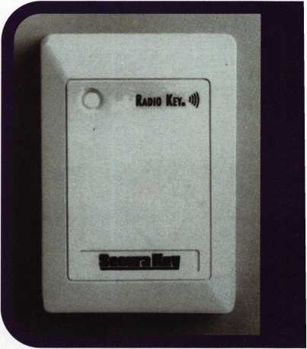

zones, one is “Always” and one is “Never.” The other 13 are up to you. The software designers have pre-loaded some common time profiles for you (like 8 AM till 6 PM, Monday through Friday) but you can change these if you wish. Each time zone displays the seven days of the week plus “Holiday” divided into 1/2 hour increments. If an increment is colored red, it is “NO,” if colored green, it is “YES.” To change from red to green (or green to red) just click on that square with your mouse. This graphical display makes it easy to read your time zones and simple to change them.

Once you have entered users and time zones to suit your project you can create “Access Groups.” These are collections of cardholders who need access to the same

December 1999

Keynotes **i**

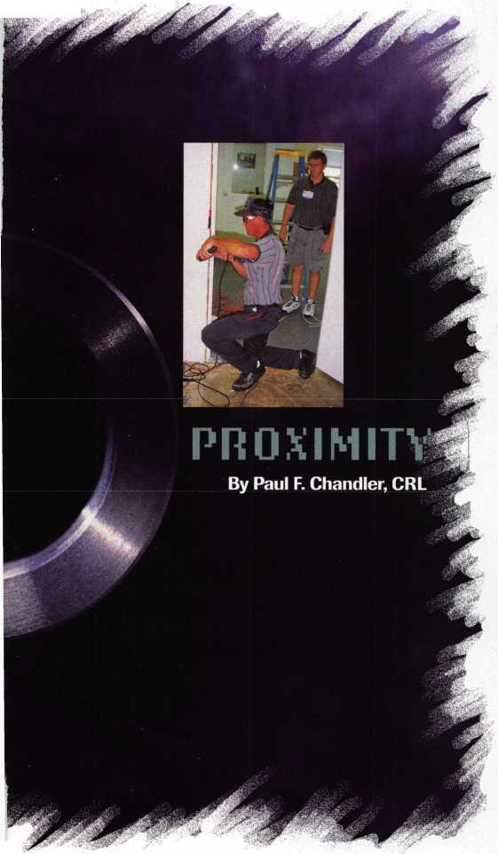

To navigate  
your locksmithing  
enterprise into the

next millennium you

need the latest training,  
product information, and  
tools. You can explore  
the entire locksmithing  
universe at one great  
show—ALOA 2000 in  
Las Vegas, Nevada.

You can also beam aboard  
the Las Vegas Hilton's  
newest attraction —  
Star Trek: The Experience.

For more information  
visit our website at  
http:/ / www. a loa.org/  
and plan to boldly

go to ALOA 2000.



doors at the same times. Examples of access groups might be “Day Shift,” “Swing Shift,” “On-Call Personnel” or “Night Cleaning Crew.” For Cincinnati, we gave all four employees 24 hour, seven day-a-week access.

Before I ever left Houston, I had activated my four cards and configured the system. With a controller and two prox readers spread out on my desk, I was able to confirm that everything was working and that I understood where all the wires go. Then, I was able to unplug everything and pack it up for shipment to Ohio without fear that my programming would be lost. The memory is non-volatile.

When we got to the IDN warehouse, the 20 students broke into teams. One group installed an HES 5000U electric strike on a wooden door frame. Another team mounted a Securitron model 32 Magnalock and a PB2E exit button at the other door. A few other students ran wire up the walls and over the suspended ceiling from the SK-ACP to the door locations. We needed six-conductor wires from the panel to each reader, two conductors to the exit button and two conductors to each electric locking device.

Although the day started off with some

serious logistical problems (a good lesson in Murphy’s Law) we made excellent time once we got started. By shortly after noon, we had the system up and running and I was able to plug in the laptop and give the class a tour of the software. Gary Linneman, the IDN-H. Hoffman manager for Cincinnati, provided us all with a splendid lunch and we were on our way back to the Convention Center.

So, what do I think of the new proximity access control system from SecuraKey? I was originally impressed by the low price. Proximity prices have fallen dramatically in the past two years and this is the least expensive equipment I am presently aware of. Suggested dealer pricing for a two-door system: controller, software and readers; is under $600.00! Throw in another $200.00 for electric strikes, a couple of transformers and some wire and you’re there.

Of course, low price isn’t always a bargain. Of equal importance is whether the system does what it’s supposed to do, whether it is easy to install and easy to program, and whether it is reliable. Well, I can’t speak on reliability yet because the equipment is new, but my experience with SecuraKey has been pretty good. They’re not

a fly-by-night outfit.

Regarding ease of installation, you couldn’t ask for much more. The readers mount with two screws and can go almost anywhere. The SK-ACP is very compact, comes in a metal enclosure with provision for a cam lock, and uses detachable terminal strips for all the field connections. The software is intuitive and uses several Windows ’95 features to make programming easy.

Functionally, the system does everything you need to do in 90% of access control applications. This is not the system for an international airport or a high-rise office building that requires individual elevator floor select. It is an excellent choice for facilities that want to easily add and delete users, to have a record of who went where and when and who might wish to restrict individuals’ access to specific days or times of day. While the SecuraKey system can handle over 200 doors, the largest segment of the marketplace is four-to-eight door applica­tions. I believe this is an excellent product for locksmiths who want to get into the fast­growing electronic access world.

I

**BE A PART OF 1-800-LOCKSMITH!  
USE THIS NUMBER IN YOUR CITY  
& OWN THE MARKET!**

We are looking for qualified locksmiths who want to expand their business

and develop themselves into one of the largest locksmith operations

in their city. You will be authorized to use our logo and name

and we will advertise for you on radio and television.

Interested locksmiths will be able to "secure"

as large or as small a territory as they

desire. Territories will be based

on zip codes.



v«

**Call today for  
more information  
or to sign upl**

December 1999

Keynotes



**taking a lesson from**

**ip producer,**

**-brand personal**

**of us have a PC with  
want us to know that**

**rol systems have**



y

JL ouve probably seen their ads in Keynotes and other industry publications and wondered, “Who the heck is HID, anyway?” It might surprise you to know that HID has been a major force in the electronic access control world for nearly a decade. Originally, Hughes Identification Devices, a division of Hughes Aircraft, the company was spun off and today is officially known as HID Corporation. HID has become one of the largest OEM manufac­turers of proximity readers and cards and they keep on getting bigger.

HID reminds me of BASF, the plastics manufacturer whose slogan is “We don’t make many of the products you buy. We make many of the products you buy better.” Products that utilize HID proximity technology are many and varied, but generally, they are identified with the manu­facturer of the “head end” and not with HID. In access control jargon, the' “head end” refers to the software and the intelligent controllers to which all of the door components (locks, readers, exit buttons, status switches, etc.) are connected. Well, the folks at HID are taking a lesson from Intel, the giant microchip

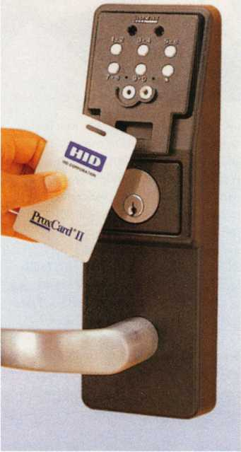

as_HID

hall be found.

producer. Nobody has an Intel-brand personal computer, but lots of us have a PC with “Intel inside”. HID want us to know that many access control systems have “Prox by HID”.

Until recently, many of the products that used HID technology were higher end systems that the average locksmith might not have been exposed to. During the past year, however, International Electronics Inc. (IEI) has been partnering with HID to offer the “ProxPoint” readers for use with their “Secured Series” family of hard-wired access

PAUL F. CHANDLER, CRL

controls. According to Lynn Carew at IEI, there will be even more cooperative efforts between the two companies in the near future. Another new product from HID is also very accessible to locksmiths. This is the revolutionary “eProx” module.

eProx is a proximity reader technology that uses very little power. So little, that it can be incorporated into battery-powered access control locks. Ordinary proximity readers are constantly using electricity to generate a radio frequency field. This would quickly drain the batteries in a self-contained

access lock but e-Prox uses a revolutionary new method of RFID sampling to make it more efficient.

The e-Prox technology has been licensed to several manufacturers who are building new products around it. At the present time the eProx partners are: Alarm Lock, Best Access Systems, Cypress Computer Systems, Ilco-Unican; Locknetics (a division of Ingersoll Rand) and a European company called Unitechniques, France. (Each of these manufacturers has launched an eProx product at this time except for Alarm Lock.)

Why should you consider installing a proximity stand-alone access lock? There are several good reasons.

Proximity is the technology of choice today. End-users seem to prefer readers that don’t require the card to be inserted or swiped. Hard-wired proximity readers often have sufficient range to read your card without removing it from your wallet or purse. While the battery-powered locks offer considerably less range, they are still easier to use than readers which require card contact.

Proximity cards are also more resistant to counterfeiting than the other popular card technology, magnetic stripe. They are also far more durable. Some facilities that might consider stand-alone access locks are unwilling to use magnetic stripe cards.

The biggest advantage of the new products, however, is the ability to integrate stand-alone locks with hard-wired access control systems. eProx units will read any existing HID 26-bit Wiegand card, and there are already millions of these in use. Consider the potential sales in an office building where every tenant carries an HID card that gets him into the parking garage. You can now offer these people a very economical system for their offices or suites with one- card convenience. If the facility does not currently have any card access you can mix hard-wired and wireless products to offer the appropriate security level for each opening at a competitive price.

For example, a building owner might want to install a hard-wired IEI HubMax system with ProxPoint readers on all of the building perimeter doors. All of the building occupants would be issued an HID card.

December 1999

Keynotes

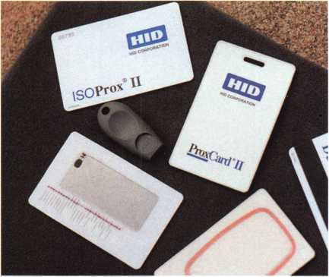

Individual tenants could now be  
offered eProx stand-alone locks for  
their personal lease spaces. Their  
proximity cards would then provide  
complete access to their workplace.

Ilco-Unican and Locknetics  
responded to my request for product-  
specific information. Here are the high  
points of their eProx offerings.

Ilco-Unican has released the “Soli-  
taireProx”. Up to 3000 users may be  
enrolled into each SolitaireProx and a  
2000 event audit trail is stored in each  
lock. Ilco-Unican offers two methods  
of programming for the SolitaireProx.

For users with basic access control require­ments, you may add and delete cardholders without a computer or software using the unique “LearnLok” technology. A set of function cards is used to perform basic programming. If the customer has more locks, or if they want to take advantage of all the advanced features of the lock, they may purchase the System 3 software package.

This new Windows 95/98/NT program allows implementation of 15 time zones, automatic unlock modes and 20 program­mable holidays.

SolitaireProx uses a 9volt battery pack and has been tested for over 20,000 openings

over an 18 month period. The lock is fully weatherized, has an ADA compliant lever and meets ANSI/BHMA Grade 1 standards. A mechanical key override is provided for use with a Medeco 6-pin or Best-style core.

Locknetics has added “Prox by HID” to their extensive line of “CM”, computer managed locks. You can choose a “PXT” model with a combination of proximity and Dallas Semiconductor TouchKey reader technologies, or select a “PXS” version which adds a digital keypad to the two reader technologies..

Locknetics CM series locks with HID proximity technology can handle 300 users and store 500 audit trail events. The four

“AA” batteries are good for 80,000  
activations or three years. These locks  
feature a patented “TorqDefender”  
clutch mechanism to protect the ADA  
lever from vandalism. These locks are  
also weather-resistant and meet Grade  
1 requirements.

Locknetics is all about versatility.  
You can get this lock in cylindrical,  
mortise, auto-bolt mortise and even  
unit lock configurations. The  
mechanical key override uses a  
standard 1" mortise cylinder, so you  
can pick the keyway you want. You  
even have five finishes of lever to

choose between.

Wireless access control locks offer the locksmith a unique opportunity in the security marketplace. Hardware installation skills, not low voltage wiring skills, are required. Door for door, wireless access control is significantly less expensive than its hard-wired cousin. The “open architecture” design of HID products makes it easy to create custom solutions for every customer’s security and budget requirements.

They may be HID but you can find them at your favorite security hardware distributors.

*NOW ON SALE!*

**6120-305 Lock w/ satin chrome key pad was $134.95**

*NOW $97.95*

**4440,4442,4443 Safe Deposit Locks (specify hand) was $16.05**

*NOW $12.95*

**6730-100 - Group 2 Lock w/ D300 dial**

**and ring was $65.00**

*NOW $49.95*

.CD®®

(*)(§)(#)

**Prices good till  
December** 23,1999

''

**7TIME Time-Master.com (web) [TIMSTR@aol.com](mailto:TIMSTR@aol.com) (email)**

**^ MASTER 888 798 8464 / Fax 800 798 TIME (8463) 785 232 8705 / Fax 785 232 2603**

Keynotes

December 1999

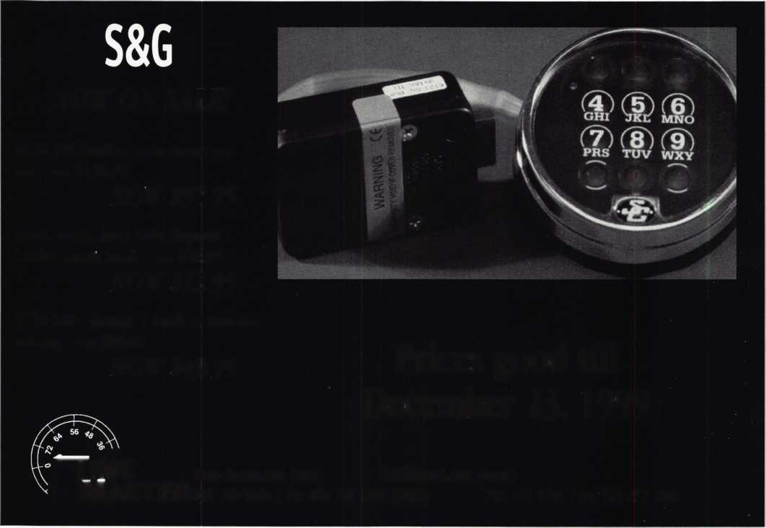

4.

Heavy Metal.

Safe and vault technicians are not strangers to the concept of how to make large metal objects rock and roll. So what better place to hold the last safe and vault trade show of the millennium than The Steel City-Birmingham, Alabama?

From manufacturers' seminars, to education, to demonstrations and more, SAFETECH2000 is your best opportunity to prepare yourself for your future.

While you're there you can enjoy the city known for its industriousness, as well as good ol' Southern hospitality. Tour the Sloss Furnaces, the Mercedes Benz factory or any of a number of museums. You can also explore the richly wooded foothills and mysterious caverns of the Appalachian Mountains.

Join us May 1 through 6 and we're sure you'll agree-Birmingham, and SAFETECH2000 rock!

For more information call

214.827.7233,

or visit our website at

[www.savta.org](http://www.savta.org)



SAFETECH2000  
WE'VE GOT THE WORKS



**STRATTEC 2000**

**PART TWff**

**by Sal Dulcamara, CML**

**FORD**

In recent years, Ford has used two different mechanical lock types and matching key configurations. Both a 10-cut and 8-cut style key is used on various Ford car models, with varying bow styles and tumbler configurations. All modern era Ford keys are double sided. The earlier STRATTEC 10-cut design had single throw disc tumblers for the door locks and side bar ignition locks that used a variation of the GM style tumblers. The more recent 8-cut design has double throw disc tumblers for the door locks and a sidebar ignition lock with double throw tumblers that look like shortened length disc tumblers. They don't operate like normal disc tumblers do, and they cannot be read the way most disc tumblers can. Some newer cars that use a 10-cut style key have locks with tumblers more like the 8-cut style.

Transponders in the varied Ford security type keys have the same basic technology, but aren't programmed the same. A transponder in the head of a 10-cut key is essentially the same as in an 8-cut key. Ford transponder locks and keys go under the name "PATS". Three different versions of PATS currently exist: PATS I, PATS II and PATS III (encrypted transponder).

A PATS security ignition lock system is mechanically decoded the same as a standard mechanical only system. The difference is that programming must follow. PATS I keys can be duplicated and programmed providing that at least one currently programmed key exists. If all keys are lost, a more time consuming process is involved, but PATS I can be serviced and programmed without special electronic equipment.

PATS I was used for 1996-1997 Ford vehicles and some 1998 Expeditions. Some 1997 Ford Explorers use PATS II instead of PATS

1. Vehicles with PATS I had the capacity to accept 16 different programmed transponder keys.

PATS II and III is found on 1998 to 2000 Ford vehicles.

Some 1998 Expeditions use PATS I. There are also some 1997 Ford Explorers that use PATS II. It is very important to know which transponder system with which you are dealing, since the programming instructions are different. For duplication, PATS II or III requires two currently programmed keys to program additional keys. If all keys are lost or even if you only have one functional key, you must have the Ford electronic diagnostic equipment in order to reprogram the system. These types have a limit of eight programmed keys.

Although an off center key ring hole in the head of the key was a common way of identifying a Ford transponder key, you can't always be so certain. A number of companies make transponder detectors to let you know if a key that you are about to duplicate contains a transponder. Ford locks that use the 8-cut style key are generally consistent on tumbler positioning, but there are some variations.

Figure 5 has a chart that identifies the different tumbler arrange­ments for the locks on various parts of a Ford vehicle.

**CHRYSLER**

After what seemed like endless changes, the Chrysler double sided key locks appear to have stabilized. It started out as a set of automotive disc tumbler locks (including the ignition) with a 7-cut key. That aspect remained unchanged for some years, but key blanks and tumbler positioning (and physical design) switched quite a few times. 1998 to 2000 Chrysler vehicles all use an 8-cut key with disc tumbler locks everywhere but the ignition, which is a sidebar lock. The ignition lock follows more closely to the mechanical model of the Ford 8-cut than the Ford 10-cut or GM style sidebar locks. The tumbler positioning is shown in figure 6.

Chrysler transponder keys are programmed similar to the Ford PATS II and III, in the fact that two currently programmed keys are required to program any additional keys, and it is also limited to eight different programmed keys. Also, like Ford, if all the keys are lost or only one programmed copy is available, it must be programmed with special electronic equipment. I didn't mention this earlier, but valet transponder keys cannot be used to program additional keys. Chrysler transponder keys are bit different in the fact that the keys are physically altered during the programming process.

If you could mechanically match the tumblers for two different Ford vehicles, you could program the same key to operate both Ford cars. All the programming does is identify the key to the car and recognize it as capable of starting the car. When a Chrysler transponder key is programmed into the system, the electronic brain in the car is programmed to recognize the key, but the key is also modified. You cannot proceed to program that key to another Chrysler car, even if the mechanical cuts are identical.

For model 2000 Chrysler vehicles, an oval shaped key head (bow) becomes standardized. In the past some had oval heads and others didn't. The Neon now has transponder security as an option. Updated software is available for the DART (Diagnostic And Repro­gramming Tool), which is a piece of electronic equipment available from STRATTEC for Chrysler key programming. I didn't list the step by step details for programming the transponder keys, in this article. That information is available from a number of sources, including free in the Ilco 1999 Auto/Truck Key Blank Reference.

December 1999

241 Keynotes



|  |  |  |  |  |  |  |  |
| --- | --- | --- | --- | --- | --- | --- | --- |
| Figure 5. |  |  |  |  |  |  |  |
| Ford 8-Cut Tumbler Positions | | |  |  |  |  |  |
| SPACE 1 | 2 | 3 4 | 5 | 6 | 7 | 8 |  |
| Ignition- All Models | X | X X | X | X | X | X | Last 7 Spaces |
| Doors-  All Models X | X | X X | X | X |  |  | First 6 Spaces |
| Deck-  All Models |  | X X | X | X | X | X | Last 6 Spaces |
| Deck-  Villager, Quest  Glove Box- |  |  |  | X | X | X | First 6 Spaces |
| All Models |  |  |  | X | X | X | Last 3 Spaces |
| Stowage- All Models |  |  | X | X | X | X | Last 4 Spaces |

|  |  |  |  |  |  |  |
| --- | --- | --- | --- | --- | --- | --- |
| Figure 6.  1998-00 Chiysler Tumbler Positions-AII Models | | | | | | |
| SPACE 1 | 2 | 3 | 4 5 | 6 | 7 | 8 |
| Ignition X | X | X | X X | X | X | X |
| Doors | X | X | X X | X | X | X |
| Deck | X | X | X X | X | X | X |
| IP: |  |  |  |  |  |  |
| Paddle |  |  | R | X | X | X |
| Twist Style |  |  | R X | X | X | X |
| Squeeze |  |  | X | X | X |  |
| Console/stowage |  |  | R | X | X | X |
| Seat Back |  |  | R | X | X | X |

December 1999

Keynotes

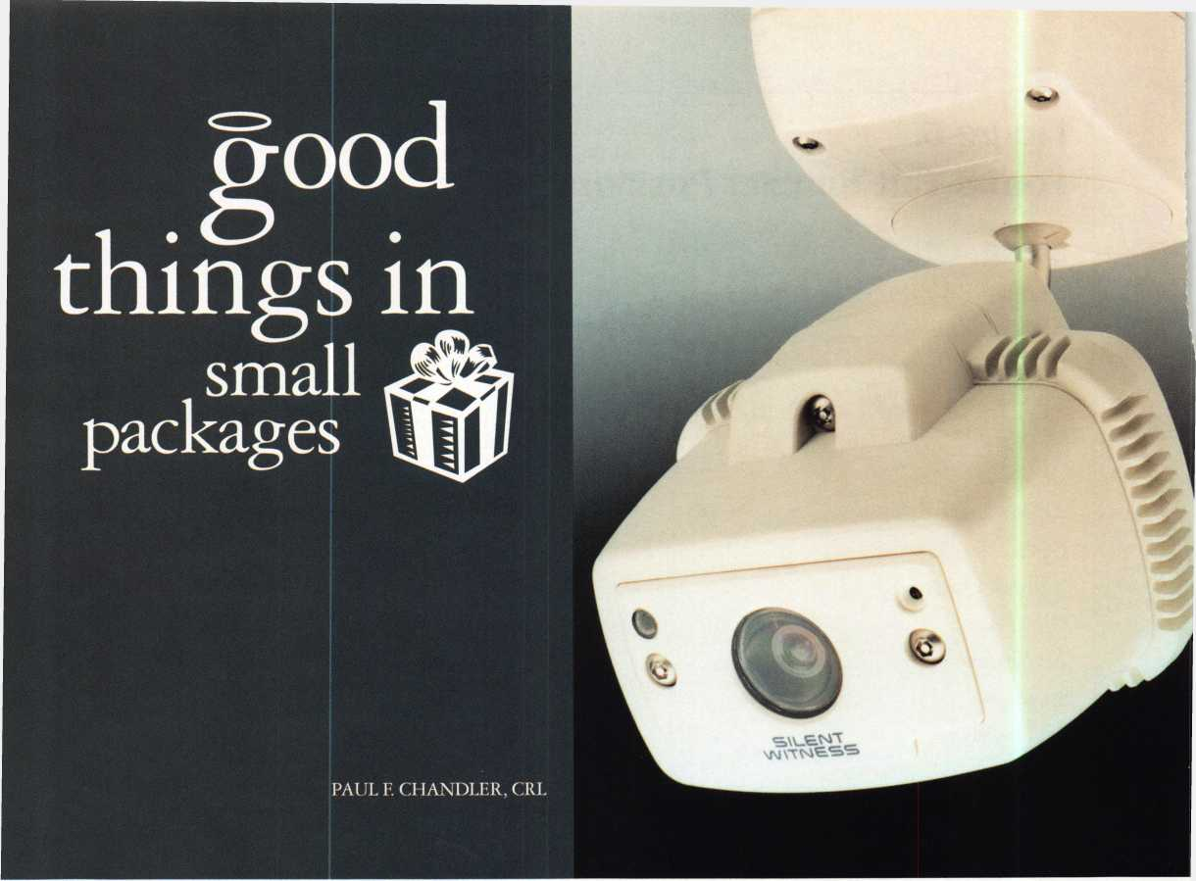

T

-L he typical closed circuit television system consists of several pieces of hardware which must be installed and intercon­nected. Every camera must have a lens, a mounting bracket and a power supply. Some camera locations require a housing for weather or vandal resistance. Sometimes a motion sensor is added for alarm inputs. The cameras are connected through a switcher, quad or multiplexer into a time-lapse recorder and finally to a monitor for viewing. In between each piece of equipment, there are cables to be pulled and connectors to be crimped. The actual installation of CCTV components is not usually very difficult, but many newcomers are daunted by the complexity of inte­grating so many parts and pieces.

A remarkable new product has been introduced that can slash the installation time and equipment costs of conventional CCTV. The SWC40 from SILENT WITNESS may very well be the first all-in-one CCTV solution. The SWC40 combines a camera, lens, video motion detector and digital video recorder in a compact weatherproof enclosure. For many applications, all you have to do is fasten it to the ceiling, plug in a transformer and point it.

(I kid you not.)

When you open the SWC40 box you will find :

1. the two-piece camera assembly
2. two plug-in transformers
3. two keychain remote transmitters
4. a package containing sundry mounting hardware, cables, security wrenches and three extra lenses and
5. the instructions.

It doesn’t sound like much, but looks can be deceiving.

The camera unit consists of a mounting base connected by a ball joint arm to the camera head. The camera head enclosure is roughly a 5-inch cube made of high-impact, fiberglass-reinforced polycarbonate with a Lexan window. The unit is tightly sealed to keep out moisture and dust. The whole thing, including the base weighs just over two pounds.

The camera features a 1/3" black and white CCD with 410 lines of resolution. With an FI.4 lens the camera requires only 0.03 lux to produce a useable picture, making it suitable for very low light situations. A 3.6mm lens comes attached to the camera, but 2.9mm, 6.0mm and 8.0mm lenses are included in the package. (12mm and 16mm telephoto lenses may also be

December 1999

261 Keynotes

ordered. These are not conventional C or CS mount lenses.)

One of the advanced features of this camera is the “Intelligent Light Compensation” technology. This means that you select which parts of the scene you want to be perfectly illuminated. Without this feature, a bright window in the corner of your image might trick the camera into adjusting in such a way that your main subject is just a silhouette.

Also built into this camera is a video motion detector that detects any relevant changes in the image. When motion is sensed, the integral recorder begins storing images and an external relay is triggered. The external relay could be tied into an alarm system. Just as you can select which parts of the picture will control the exposure, you may also select which areas the camera should monitor for motion. This permits your camera to ignore irrelevant movement at the edge of the scene and respond only to action in the key areas.

Once triggered, the camera has a built-in digital video recorder that can be set to take still pictures or time-lapse video for a preset amount of time. Up to 1140 still images, or as much as 95 minutes of time-lapse action can be stored in the non­volatile memory. The date, time and location is imprinted on these images. Recording can be started either when the camera senses motion, or you can connect the unit to an external sensor such as a door contact switch or a relay output from an access control card reader. Digital recording doesn’t use videotape, the data is stored in a reusable memory chip.

Of course, you don’t necessarily want the unit recording all of the time. That’s why they give you the wireless remote controls. When you’re about to leave for the evening, you can click the remote to arm the camera. You then have 60 seconds to leave. After that time, the unit will respond to any motion it detects and record the action. When you arrive the next morning, you disarm the camera and look at the LED on the camera face. If the LED is flashing, you’ve caught somebody. If it isn’t flashing, don’t worry. There’s nothing to look at.

How do you look at your stored video? The SWC40 can be connected to a monitor or to a conventional television for playback. You can also connect it to a standard VCR for permanent storage of the images. There are two ways you can plug in your monitor and access the rewind and play controls for video playback. With the supplied security wrench, you can take off the face of the camera enclosure and plug a portable monitor into the ‘video out’ jack located there. Or, if you prefer, you can just as easily remove the entire camera head from the mounting base and take it to your TV set. A second video jack and set of controls are located on the back of the camera head for your use. The extra transformer they put in your box can be used to power the unit when it has been removed from the mounting base.

In some installations you may choose to connect the SWC40 to a permanent monitor so live video can be seen. Provision for connecting both live video and audio outputs are provided in the mounting base part of the camera assembly.

Just consider some of the applications for this unique CCTV system-in-a-box. The first use that jumps to mind is after-hours surveillance. Just like you set your alarm before walking out of the office, you can arm your camera. If any intruders break in, or

if a rotten-egg employee comes back in with his key for some illegal moonlighting, you’ve caught them red-handed. You can even use the video motion sensor to trip your security alarm system and summon the police.

What about monitoring activity in a restricted area? An SWC40 could be installed in a tool room, a narcotics closet or anywhere that you might want to record who’s coming in and what they’re doing.

If you install electronic access control, the SWC40 can add positive identification to your system’s audit trail. Just connect an auxiliary relay output of the access controller to the camera and take a picture of everyone who swipes their card.

An SWC40 can be connected to any type of electronic system to begin recording when an emergency is detected. Intrusion, fire, chemical, water or gas detectors can initiate video recording of the event for later review.

Places that handle a lot of money, like check cashers and supermarket courtesy booths, can take a snapshot of every customer who approaches. Convenience stores and all night gas stations can connect the camera to a holdup alarm or set it up to record whenever the safe is opened.

The Silent Witness SWC40 is pretty amazing, but it won’t eliminate the market for conventional CCTV. However, it does provide an alternative solution for many common applications. And it may be just simple enough to get you off the fence and into the profitable world of closed circuit television security.

o oeooeooeooeoo

o

•

o

o

•

o  
o

•

o  
o

•

o  
o

•

o

Keedex has a new Tamper Resistant Screwdriver. This screwdriver comes with eleven interchangeable tips. Includes the following:

A Six tamper resistant torx tips ^ (T10, T15, T20, T25, T27 & T30).

**Q** Three tamper resistant hex tips V (5/32", 3/16" & 7/32").

Two Spanner Tips (#6 & #8).

All tips fit into the screwdriver's storage handle. Invaluable for automotive work, lock work, access control and more.

Your Source For Tamper Resistant Screws!

Qy Keedex, Inc. • 12931 Shackelford Ln.

•

Garden Grove, CA 92841 • 714-636-5657 • Fax: 714-636-5680 ^  
[www.keedex.com](http://www.keedex.com) • e-mail: [info@keedex.com](mailto:info@keedex.com) Qy

ooeooeooeooeoo

•

o

o

•

o

o

•

o

o

•

o

o

December 1999

Keynotes

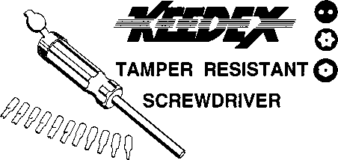

need to p; ■ friend, m

raving n

:ember 1999

when i

good

^employees

go

by Tim McMullen

It is one nightmare that every business owner dreads: the realiza­tion that one of your employees is stealing from the company, stealing from you. Every manager or business owner takes pride in thinking that the person they’ve just hired will be a good employee, one that will be responsible and help the business grow. Once in a while, however, you’ll hire someone who does not have your interest at heart. This can be a new employee or even a long-term employee. Regardless, there are steps you can take to identify a potential problem, and ways to proceed if this situation should arise.

The U.S. Chamber of Commerce reports that an estimated 30 percent of all business failures can be directly traced to occurrences of employee theft and an estimated $53 billion is lost each year due to employee dishonesty. Perhaps more pointedly, American businesses lose more each year from employee dishonesty than they do from fire.

Most people assume that there are risks inherent in all businesses. The question arises as to how to effectively manage the risk of loss due to employee dishonesty? Frequently, employers are not aware of the potential financial impact of an employee dishonesty claim on their business.

The truth is that any one of your employees could be stealing you blind. All it takes is motivation, opportunity and rationalization.

* Motivation: Employees may be have real or perceived needs for money often to support excessive lifestyles or addictions such as drugs, drinking or gambling.
* Opportunity: Your most loyal trusted employees are often the individuals who steal from you. They have been with you for years and you have placed your trust in them. And of course, who would be in a better position to steal from you than the employees you trust the most and are familiar with your systems.
* Rationalization: Many employees look at their dishonesty acts as simply business transactions, not a crime. Crime to them is something dirty and violent. They’re not stealing—they’re borrowing your money, fully intending to pay it back someday.

Too often, that “someday” never comes.



Some of the more common situations involving employee dishonesty include, but are not limited to:

* padding payrolls and cash expenditures
* falsifying and altering time cards
* billing goods at their real price, then entering reduced prices on

the books and pocketing the difference

* stealing from the cash drawer
* failing to enter cash sales or credit cash payments from

incoming payments

Recently, an ALOA member in Asheville, North Carolina found out that one employee had embezzled $12,400! Still, another ALOA member in Houston, Texas found out that one of his employees was actually on call for the company all the while soliciting business for himself. He would approach the customer (in company uniform), and let them know that the company was going to charge him a certain amount, but that he could do it on the side for less. He would then contract the piece of business for himself, using company tools and hardware. Sound familiar? This would have gone on for awhile, however, one of the contractors that this company had worked with for a long while blew the whistle. But what were some of the warning signs? Long periods of time not on radio contact, late for work repeatedly, number of sales totals below average, overall not a very good employee - but one which at times could shine, and make you forget about the other stuff.

What can you do to an employee who you find has been stealing from you (in whatever form that may take)? There are a number of civil and criminal actions that you can take after the fact, but those may vary state-by-state, and would need the consultation of a lawyer. It is also very important that you have documentation that these incidences actually occurred. In the Houston case, the contractor the company worked with sent them a letter completely outlining what this employee had done. You may also want a separate, trustworthy employee follow up on all (or random) dispatched calls to make sure the work was performed to the customer’s satisfaction and that the customer was billed for the same amount contained on the invoices returned by the employee. This would especially be helpful where the customer paid cash for the services since it would be easy for the employee to bill on his own invoice the actual amount, and bill on the company’s invoice a reduced amount, so that he can turn in the reduced amount and keep the extra cash.

When investigating an employee, however, you must be careful. Recent changes in the Fair Credit Reporting Act that could have impact on businesses in the security industry. The staff of the Federal Trade Commission has advised that amendments to the Fair Credit Reporting Act (FCRA), which became effective last year, require employers to inform the subjects of inquiries when they are under investigation. The law affects all outside investigators, consultants and attorneys hired by employers to conduct investigations of fraud, embezzlement, sexual harassment or inventory loss. Under the FCRA, employees must actually give their permission for an investi­gation to be conducted. In the unlikely event such permission is granted, employers are then required to turn over all evidence collected to the person being investigated in an unedited form.

One area of insurance coverage that is often ignored and generally not purchased by a locksmith business is Employee Dishonesty Coverage. Typically, this is accomplished through the placement of a Fidelity Bond. It should be noted that the cost tends to be minimal

though the impact of a claim can be staggering to the health and welfare of a business. Ironically, clients that do not currently carry crime insurance often do not recognize the need for coverage.

There is little doubt that a good system of internal controls is an excellent business practice. However, no system is perfect. Often, internal controls can break down or be circumvented. Clearly, the combination of having the internal controls in place and conducting background checks is an adequate first line of defense against employee dishonesty. An enhanced “belt and suspenders” approach is purchasing blanket crime coverage with adequate limits. Together, this strategy can serve as a relatively inexpensive safety net when counted with strong internal controls.

Although the treat of an internal defalcation is ever present, employers cannot forget their exposure to third party claims arising out of the actions of their employees. In essence, this endorsement expands fidelity coverage for employees working outside of your premises and protects the assets of your customers against theft by your employees. It also has the added benefit of serving as a marketing tool when a customer asks whether or not you are bonded. The third party coverage endorsement is the ideal way to round out the protection offered under the Fidelity Bond.

Special Thanks to Sheri London, ROSS & Company Insurance Services and Jeffrey R. Matthews, Esq. for assistance with this article.

qet fdS

Automotive Locks, Keys, Service Kits, Manuals & Training  
for the Professional Locksmith

VATSmiths!

3**^**4:0 **m pone]**

**inexpensive VATS Replacement locks and keys from  
BWD Certified VATS Centers. Plus, become a Certified  
VATSmith through BWD's VATS Certification training.**

**For a list of BWD VATS Centers and a Seminar  
Schedule, see offer below.**

**FREE!**

1999 **Illustrated Automotive Parts Catalog**

**including BWD Service Manual Library Centers,Distributors,  
VATS Centers, Seminar Schedule, and more... call**

**(800) 647 4926**

**or take your web browser to [www.alllock.com](http://www.alllock.com).**

December 1999

Keynotes

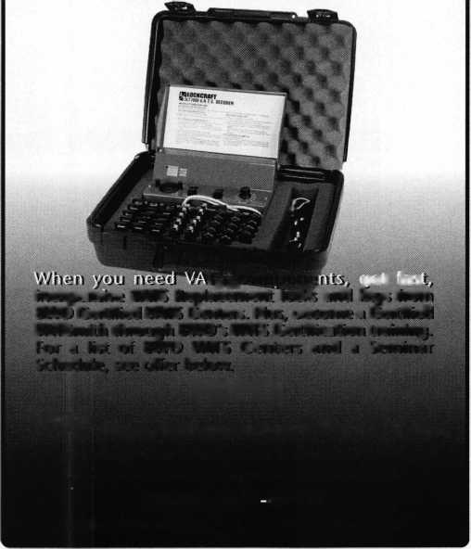

* Super bearing construction.
* Superior rigidity and accuracy.
* Shipped with carbide cutter.
* 2 year parts and labor warranty.
* Increased cut rates:

Laser mode 8 sec

Standard mode 12 se

Bi Axial 6 pin 17 se

* New Medeco Autoswing head option,

tDQjmp©

mUHBSB

(OMUnoa

□GDHQB

WEAR EYE PROTECTION

* Up to 800 built-in manufacturer depths and spaces.
* Works with most popular Master key systems.
* Serial port to communicate with user systems.
* Repeatable accuracy of l/1000th inch.
* Dependable heavy duty construction.
* 1 year parts and labor warranty.
* Cuts Medeco™ High Security keys with angled cuts.

The ITL 9000 was built by locksmiths — we know what you wanted so we built it. When a new lock comes out you add the space and depths immediately. No Mechanical adjustments. All sealed and prelubricated bearings.

ITL -9000

GJGQEJOD

QdHDDD

EDGDGDDD

* Uses either 12 or 120 volts.
* All manufacturer depths and spaces built in,
* Heavy duty construction.
* 12 month warranty.
* Built in Master key System.

TOOLS LIMITED

— **Now Distributed Throughout USA, Canada & Australia** —

2639B Progressive Way • Abbotsford, BC Canada V2T6H8  
USA: 562-699-0060 • Canada: 604-852-8904 • Canada Fax: 604-852-8938 • Toll Free: 1-888-264-6627

|  |  |
| --- | --- |
| iotmi | HE |
| mm© | 88 IB |
| BE® | El S3 |
| IB ini | mm |

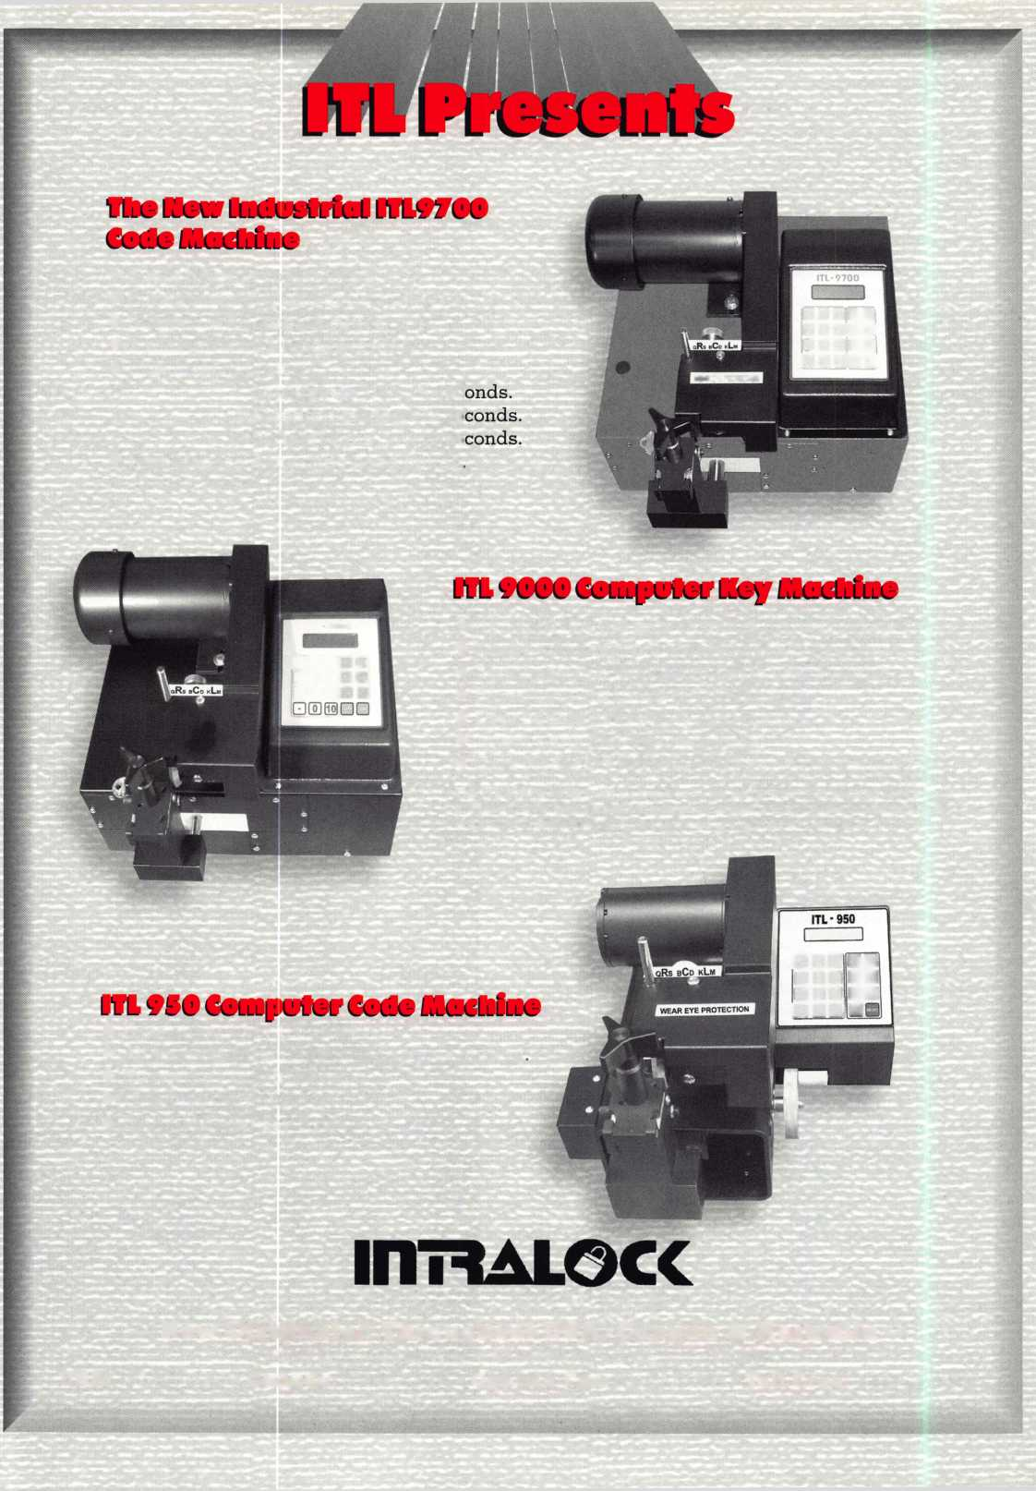

**Competition can be downright serious in today’s business climate. When the field of competitors seem to have look-alike product lines, cutting costs and having the lowest price is often the measure of the rivalry. This type of environment has inspired an interesting trend, sometimes known as niche marketing. Instead of trying to look like everybody else, you create products that are different and that aim for customers and markets not sufficiently served.**

**Noble Security is a company that seems to fit that bill. Their booth at the recent ALOA show (photo below left) displayed many of their different and specialized products.**

**From new concepts in padlock/hasp design to specialized security products designed to protect computers and assorted periph­erals, Noble Security products stand out among many of the look-alikes.**

IN THE BEGINNING

**Noble Enterprises had its beginnings in 1990. Meir Avganim, shown in his booth in photo below right started the company as a provider of high quality CNC (Computer Numerically Controlled) metal machining works and metal production in Israel. An engineer trained in precision machining, Mr.**

**Avganim developed a line of unique and innovative security products. In 1995, his son Gady Avganim helped to set up sales headquarters in the United Kingdom (for the European market) and Los Angeles, CA (North American market). The company has a licensing agreement with Smith & Wesson for all its products except for the gun lock line.**

**Noble Enterprises has an R&D (research and development) staff of 28 highly skilled**

**people. Metal machining is accomplished with CNC equipment, for precision and quality. The plant operates under the ISO 9002 quality management approved status.**

**by Sal Dulcamaro, CML**

THE PRODUCT EINES

**Computer Locks. While Noble makes a variety of generic computer locking devices, they make patented locking devices**

**for specific models of Dell and IBM chassis designs.**

GUN EOCKS.

**Their gun locks include a variety of portable and mounted locking devices. They are designed for theft resistance and safety. Gun locks from Noble Security are not licensed to use the Smith & Wesson name.**

S HACKEE FREE EOCKS.

**Noble has new concept “padlocks”, that are shackle free. Instead, they use a special combina­tion of integrated shackle free “padlocks” and hasps. They are designed to minimize exposure to bolt cutters, while improving the look to make them more aestheti­cally pleasing.**

RAIE EOCKS AND EOCK DOWN SYSTEMS **Rail locks can be attached to cases and containers, with mating parts attached to immovable objects. They make it difficult for someone to walk off with expensive equipment. Locking cable devices can be used to lock down anything from adding machines to computers to televisions.**

PORTABEE CABEE EOCKS **For security on the go, the portable cable locks can be used with laptop computers or other portable but expensive products, to prevent someone from walking off with your expensive equipment.**

**For more information and details on the product line, contact: Noble Security Systems, Inc., 5325 Newcastle Ave., Suite 202, Encino, CA 91316. Phone: 888/446-6253. FAX: 888/336-6253. E-mail: [noblesec@loop.com](mailto:noblesec@loop.com), or see all their products on the web at: [www.golocks.com](http://www.golocks.com).**

FINDING A



The Only * Way To

*k*

n Computer "Security!



“ * DeskTops

*m*

fee *MM Towers • Notebooks

§.* Primers / Fix |*apDrtve/ltedems

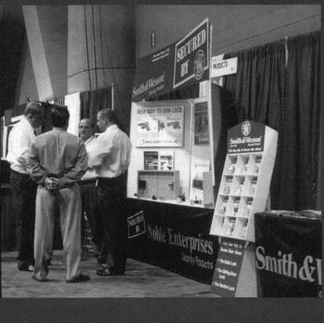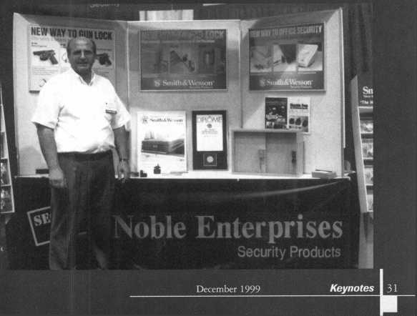

**The Woes of Inventory**

By Don Dennis, CPL

There are lots of plans on how to stock inventory. In order for any of these plans to work, you have to catalogue your business into a particular category. Are we service or are we in the retail category? Whatever category we may be categorized under, we are supposed to buy our inventory based on past performances. The trouble is that one years sales does not reflect what will happen in the future. If your area was exploited by burglaries last year then you don’t want to load up on deadbolts if the culprits are in jail.

My business has seen many stages. When I was new to my area,

I did a great deal of automotive work. It was the easiest to get and therefore, I was loaded with locks, pinning kits, lock cover caps, and key blanks for autos. My next phase was delving into the safe industry.

I sold safes, drilled safes, serviced safes, and when time allowed I did what automotive work and residential work came my way. Then came the shop location. It was a terrific move except for the requirements for inventory. Telling a customer that you didn’t have a product in person as compared to over the phone is a drastic difference. On top of all of this the market place was changing with the strong advent of the big chain stores that dealt with home improvements. The do-it-yourself market arrived like gangbusters and I moved with firm determination into master keying and a solid alliance with the business community. Each side of our business requires a different kind of locksmith and a different requirement for inventory. How does one find an answer for inventory when so many styles exist?

The closest answer is in a term (imported from Japan), called Just- In-Time Inventory. Remember that it is the closest answer not the only

PRISON and JAIL LOCKS

mnnfliSSffl

Qeorg,e c*4*. Keene, *3*nc.

1101 NIAGARA FALLS BLVD.  
BUFFALO, N.Y. 14226  
PHONE 716-832-0180  
FAX: 716-832-5422

32

answer. Our supplier network has evolved over the years. There was a time when every supply company had people on the road drumming up more business. They were visiting new customers and becoming reacquainted with old customers. The sales person brought the monthly sales with them and you placed your orders at that time.

Now we may see an occasional sales person visit us and sales flyers arrive monthly. The pressure presented by the supply industry was using the telephone to place your order and the locksmith responded.

It was easy, and a quick way to place an order and we could use next day or second day air conveniences when needed. This evolved into a way of doing business with smaller inventories. It is this that makes the locksmith fit into the just-in-time inventory concept.

There is not any magical formula for figuring how much inventory to carry on your shelves. It all depends on events and circumstances that surround your particular business. We all are very susceptible to using the conveniences offered by current ordering systems. We are busy going from one call to the next and when we finish the day, we want it to be over. We make a quick call and order what we need and then it is finished. We really do not consider the cost of what we have just done. Many times this becomes our undoing. It is not the supplier’s fault. He is only providing us a way to meet our needs. It is our fault!

Even if we use the seat-of-our-pants approach combined with just- in-time inventory practices, we must stop, think and plan. We need to think of what it is costing us to do business this way and how we can improve upon it. Since we all commonly use anywhere from three to ten suppliers to meet our business needs, we need to look at what each supplier can offer us. This includes the product cost, the freight cost, handling fees, late payment finance charges and who will extend your credit. This includes evaluating the speed in which the order arrived and if it was properly filled.

There is also one other thing to consider before we order an item. Is the customer locked into the purchase of the item? If they are not committed, by a contract or by earnest money paid, then what will you do if they refuse it? You could return it to the supplier with penalties but many of us would simply hold on to the product with thoughts of selling it before the year’s end. Then we wind up not selling it and paying taxes on it and trying to sell it the next year. Well, there is a way around all of this.

Take your product and donate it to your local association. This way you can take the full cost of the item off your taxes at the end of the year. Then the association can try and sell it to another member of the association placing any money made into the association’s treasury. If it does not sell, the association can donate all items collected and not sold to NAEIR. NAEIR is The National Association for the Exchange of Industrial Resources. They accept donations and they have members that pay for their memberships. When the warehouse is full and needs emptying, they make their calls to their membership and they give away their inventory. NAEIR is therefore a tax-exempt corporation.

It becomes a win-win situation for everyone involved.

My correspondence with NAEIR, indicated that they deal with associations where there would be enough materials involved. They would be interested in most everything except key blanks. All items would need to have proper boxing and be stand-alone items. They usually deal with manufacturers where the write-offs are 150% of cost. Deductions for “S” Corporations, partnerships, and sole proprietors are a straight deduction of cost only. Each association would need to make individual contact with NAEIR. My contact was Jack Zavada at 1-800-562-0955 ext. 205 or via e-mail at [jez@naeir.org](mailto:jez@naeir.org).

Keynotes

December 1999

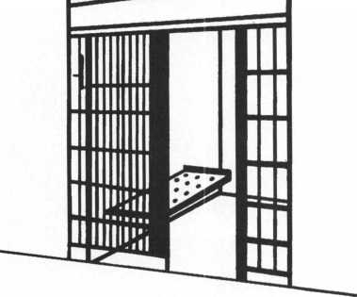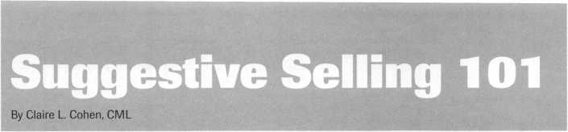

“Suggestive selling” maximizes sales. It’s a simple approach most businesses can implement quickly and achieve immediate results. If your locksmith business can benefit from a higher sales volume, consider using suggestive selling.

Suggestive selling is a technique designed to get more money at the point of sale. Your “upsell” by offering your customers a related item (or items), multiple items or the choice of an upgraded product at the time they are making a purchase. Customers will never be more receptive to an attractive offer from you than when they are ready to make a purchase.

Most likely, you often experience suggestive selling techniques. Mealtime comes and you are off to the local fast food chain. You are asked, “Do you want fries with your burger?” Have you ever called to order a product advertised on TV? It is likely that the customer service representative automati­cally offered you an additional related product or a special discount only available if you ordered it right then. You could you apply these same techniques to your business.

Many businesses avoid suggestive selling because they are afraid the customer may get irritated and not buy at all. Just the opposite is true. Customers appreciate your thoughtfulness in advising them of other choices available or offering them an added benefit they didn’t know existed. This is especially tme in the our specialized field, as many people are not familiar with product lines and services offered by a professional locksmith. It’s important to remember that we are professionals, and don’t want to sell our customers goods and services they don’t need!

Some business owners feel they don’t upsell because it is not feasible in their business. They really believe that until they hear about the suggestive selling offers used successfully by some of their competitors. The majority of businesses, be it locksmith or other, can benefit from imple­menting a successful suggestive selling program.

Years ago, I took a sales course taught by a career men’s clothing salesman. In his store, strate­gically positioned between the suit department and the cash register, were shirts and necktie displays. My teacher spoke of using suggestive selling technique after the customer decided to purchase a new suit. On the way to the cash register, he casually walked to the shirts or neckties and suggested that his customer consider purchasing a shirt (or necktie) that would go well with their new suit. Not only were his customers receptive to his ideas, they THANKED him for sharing his idea with them. A large percentage of his customers would buy at least one extra shirt or necktie,

What to Offer?

After taking the class, I came back to our shop and decided to try my newly learned technique. It couldn’t hurt to try. All the customers could say was “No.” My first customer came into the shop, and needed one key cut. He told me it was a replacement key for a boat. The original key had

fallen in a lake and sank. Armed with suggestive selling, I decided to try what I had learned. I told the customer, “We do have unsinkable key floats to prevent this from happening again.”

He responded, “That's a great idea—I’ll take two!” My initial success was one example (and a small dollar amount). But imagine over the course of a day, a week or a month, how much this can generate. You’ll find that successful selling techniques will work quite well with larger sales too!

Every business is different. Think about your business. What can you offer customers while they’re making their transaction with you? Can you offer them:

* a product or service which goes along with their initial purchase?
* decorative trim plate available with a doorknob?
* a second padlocks (keyed alike)?
* a discount on a related product or service?
* the opportunity to buy a deadbolt and a door knob and only pay $X to have them keyed alike?
* a volume discount if they buy more now?
* a specially priced combination package including the initial products or service?

You will find that many of your customers will accept your suggestive selling offer when it’s a good fit to their initial purchase and a good value. Presenting the Offer

Suggestive selling has none of the characteristics usually associated with selling. It is so easy. Many “order takers” achieve high acceptance rates by reading from printed scripts. Suggestive selling is simply offering a suggestion to an already receptive buyer to enhance the value of his or her purchase. Present your offer casually, almost as an after­thought. For example, if you were speaking with your customers in person or by phone, you might say: “Your rekey will include two keys. If you’d like, we cut extra keys for this lock at a reduced cost.” You can make the same offer on paper or post it on a sign. It doesn’t have to be verbal to be effective. Businesses report acceptance rates of between 40 and 60 percent for their suggestive selling offers. This is a big increase for so little effort. Plus, the revenue from the suggestive selling portion often exceeds the dollar amount from initial product or service Spend time preparing a “game plan” where you make lists of items that can be offered using suggestive sales techniques. Of course, there is no better way to use suggestive selling than to be sure that all of your salespeople are knowledgeable about your products and services and represent your business as that of a security professional. If you’re not making suggestive selling offers to every customer, start doing it now. Be creative with your sales initia­tives. Your only limitation is your imagination! Train everyone in the company to use these techniques. Multiply your profits quickly with little effort.

SECURiTyg

LOCK COMPANYBV

**New** Factory Replacement Parts and Locks for Security Corporation and Kumahira Safe Co. Products

* Safe Deposit Box Locks and Parts BX, KD
* Automatic Remote Tube Systems (ARTS)
* Drive Up Systems
* Vault Doors
* Night Depositories
* Camera Systems
* Key Blanks and
* Keys Cut to Code

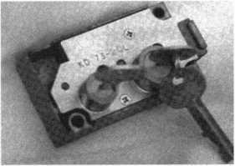

KD Series

Safe Deposit Box Locks

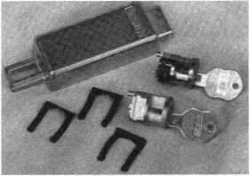

BX Series Safe Deposit Locks

1155 Chess Drive, #114 Foster City, CA 94404 Phone: (650)525-0660 Fax: (650) 525-0444

Email:

[chaslutz@securitylockco.com](mailto:chaslutz@securitylockco.com)

SEClIRITygB

LOCK COMPANY HV

December 1999 Keynotes

**Keynotes**

Classified

Dept’—

**Classified Advertising Policy**

**Classified advertising space is provided free of charge to ALOA members, and for a fee of $.60 per word, $15 minimum for non-members. Classified ads may be used to advertise used merchandise and overstocked items for sale, “wanted to buy” items, business opportunities, employment opportunities/positions wanted and the like. Members or non-members wishing to advertise services or new merchandise for sale may purchase a “Commercial Classified Ad,” for a fee of $1.30 per word, with a minimum of $40. Each ad will run for two issues. For blind boxes there is a $5 charge to members and non-members. All ads must be submitted in writing to the ALOA office by the fifteenth of the month, two months prior to issue date. Send to Keynotes Classifieds, 3003 Live Oak SL, Dallas TX 75204-6186. ALOA reserves the right to refuse any classified advertisement that it deems inappropriate according to the stated purpose of the classified advertising section.**

■ EMPLOYMENT Experienced Service & Shop Technicians Needed

12/F/3: Due to continued growth, we are looking for outside and inside service technicians. Our company has been in business since 1880 and is located in the beautiful Pacific Northwest. Argens Incorporated is a multi dimensional company. We target commercial and industrial accounts of all sizes. Our company specializes in general locksmithing, electronic security (card access & CCTV), door servicing and gate systems. We are an employee driven company with excellent pay, benefits, sale incentives and can offer advancement as our growth continues. Send resume to:

Jim King Argens Incorporated 84 S Main Street Seattle, WA 98104 (206) 623-2662 (206) 622-3036fax argens@w-link. net

Experienced Technician Wanted

12/F/3: Family owned business since 1911, serving Knoxville and surrounding areas in East Tennessee are in need of experienced commercial, industrial and residential technicians. Must supply background check, work and personal references, have a clean driving record, no felonies, able to work as a team player, neat, honest and good communication skills. Salary with monthly and yearly bonuses. Insurance and retirement plan after 90 day trial, paid vacation and sick days after one year. Send resume and cover letter to:

Attn: William M. Peters Jr., CRL F. M. George Safe & Lock Co., Inc.

P0 Box 3398

Knoxville, TN37927-3398

Locksmith Wanted

12/F/3: Relocate to South Florida and throw away your deadbolts and three keys for a dollar. We run over 300 calls per week. You must own a tmek with tools and code equipment to cut all foreign and domestic keys. You can earn $800 to $1500 per week. Please, if no truck or tools, do not call.

South Florida Lock and Safe (800) 928-2926

Service Tech Wanted

12/F/3: Established locksmith company is seeking service technician with commercial experience. Must be professional and ambitious. Qualified technician can earn up to $18 per hour. Medical insurance, vacation, plus other benefits. Submit resume.

(362) 464-0333 (362) 464-0333 fax

Experienced Technician Wanted

12/F/3: Join a fast growing 23 year old firm in America's #1 place to live, Nashua, New Hampshire. Top wages in area paid to career oriented professional with excellent benefit package.

New Flampshire Safe and Lock 343 Amherst Street Nashua, NH 03063 (800) 838-0132 (603) 889-2849fax nhsafelock@aol. com

Locksmith

1 l/F/3: Company doing services for financial institutions has a great opportunity for a general-purpose locksmith to service the Seattle area. Must have vault and safe experience. Competitive salary, benefits and company vehicle provided. Clean driving record required. Fax resume to:

Attn. Grant Driskill (303) 670-0743

Locksmith Wanted

10/F/3: Locksmith wanted in Dayton, Ohio area. Top notch shop in affluent suburban community. Great sales commissions for right individual. Must be versatile, bondable and reliable. PRP status a plus. Relocation compensation for the right person.

Roger Krass P0 Box 0028 Dayton, OH 43441

Locksmiths Wanted

10/F/3: Pittsburgh! Pittsburgh! Pittsburgh! Must have own vehicle and tools. $1,000 per week guaranteed!

Call today and ask for Mike:

(800) 926-8881 mdicieco@interstatelocksmith. com

Commercial Locksmith Wanted

10/F/3: ASAP Opening in Denver for a Commercial Locksmith. Safe and Access Control beneficial. Promotable opportunity. Strong salary, bonus and benefits.

(303) 893-0639fax phyllis@phillips. personnel, com

Locksmith Wanted

10/F/3: Immediate opening for an experienced technician in the “Land of Enchantment,” Santa Fe, New Mexico. Requirements include three years minimum experience in areas of master keying, auto lock and general field work. Good driving record essential. Salary $40-$60K plus benefits, including company equipped van and paid vacation after first year. Retirement plan also available. Send or fax resume to: AB 1 Locksmith Service 1913 Cerillos Road Santa Fe, NM 87303 (303) 983-2690 (303) 983-3022fax

Locksmith Wanted

10/F/3: Chicago area mobile locksmith service seeks an experienced locksmith.

Must have own tools and car. Please call: (708) 436-6198

Keynotes

December 1999

Keynotes

Classified

Locksmith Position Opening

10/F/3: The Kenton County Airport Board has an opening in the Building Maintenance Department for a locksmith for second shift (3 pm-1 am) Monday-Thursday. Applicant must have a high school diploma and five years working experience, with complete references available, in the trade of commercial locksmith. Applicant must have the knowledge of the materials, tasks and methods used in commercial locksmithing such as master keying, repair and installation of locksets, hollow metal doors and frames, door closers, panic devices, Simplex combination locks, electronic alarms and various other locks associated with locksmithing; the ability to use many locksmith tools; ability to prepare rough sketches of work and estimate of materials and labor; ability to carry out verbal and written directions; ability to work with others. Must be a holder of a valid operators license. Competitive salary and benefit package.

Apply in person or send resume to:

Human Resources Kenton County Airport Board PO Box 752000 Cincinnati, OH 45275-2000

Locksmith Wanted

10/F/3: Perfect Opportunity for the right entrepreneur. Work as a locksmith for the company that could be yours. Original owner plans to sell the business within five years, so you can get to know the business while working. Inside/Outside technician needed with experience in master-keying, interchangeable cores and auto locks. Business established in 1969, consists of highly visible retail location, two well-equipped vans and four full time employees. Located in Queens, New York, we serve many commercial accounts, especially at both airports.

Fax letters of interest to:

Eric

(718)845-1717fax

Locksmith Wanted

10/P/3: Leading Louisville, KY Locksmith Company looking for experience and organi­zational skills. Offering competitive salary with bonuses, health insurance and profit sharing plan. Call and/or send resume to: **Attention**: **Bryan Turner Willis Klein Safe, Lock, Decorative Hardware 4041 Westport Road Louisville, KY 40207 (800) 928-LOCK**

m BUSINESSES FOR SALE Business For Sale

10/F/3: Tired of the Rat Race-Heres the ideal situation for someone who wants to raise a family in the upper Mid-West or seeks a more civilized environment and still make a living comfortably. Established in 1980, we specialize in Commercial and Institutional accounts with CCTV-High Security Locks and Access control Systems. In the heart of Wisconsin with an excellent hospital and one of the nations largest privately owned medical clinics. Downtown walk-in shop location-little competition.

(214)827-1701

■ WANTED TO BUY/SELL Tryout Keys, Depth Keys For Sale

10/P/2: Aero Lock does not use key duplicator machines to produce its tryout keys or depth keys. Only original computer controlled code cut. Buy the best.

Aero Lock

3675 New Getwell Road **#9** Memphis, TN 38118 (800) 627-9433; (901) 362-1197fax aerolock@ix. netcom. com httpillunvw. aerolock. com

Excess Stock For Sale

10/F/3: Large assortment of Schlage Keyblanks, both original and look-alike in these series 35- 180, 35-200,35-100, 35-101, for sale plus an assortment of miscellaneous key blanks such as: Chicago, Illinois, Corbin and National (cam lock), ILCO (older auto), Slaymaker and misc (padlock), Yale, Ruswin, Sargent, Segal, etc. (Cylinder) and many others. I should have them cataloged soon and will send a list if you are interested. Also available is a Medeco double cylinder deadbolt lock, US 3, 2 3/4" drive in, restricted keyway, PN 11 W 0102 05 G 3- quantity 8 each, $45 each.

Call (505) 526-4106

For Sale or Trade

10/P/2: For sale or trade, door closer service equipment and parts in LCN, Corbin,

Russwin, Yale, Norton and Lockwood for $1500. Contact:

Bryan

Willis Klein Safe, Lock, Decorative Hardware (800) 928-LOCK

Wanted To Buy

1 l/F/3: Wanted used 1200 HPC Machine **Call: (301) 627-5876**

Locks For Sale

10/F/2: Marks Mortise Handle Sets 625, Schlage D & L series, Schlage F51PD Clairmont 616, Sargent Rim & KIK cylinders , Sargent Locksets, Yale Locksets, Yale Rim and KIK cylinders, Medeco cylinders Commercial 00 keyway, Medeco cylinders SKY 04 keyway, Medeco cylinders GLD Biaxial, Dexter Locksets, and Von Duprin 88EO x626. All locks are new w/ assorted keyways and finishes. If interested please call for quantity and prices.

Jennifer Renderer

(305) 944-0469

Wanted To Buy/Sale

12/F/3: Old key blanks, Hurd, Briggs- Stratton, Yale, etc. I will pay $1 each. Send me a list of what you have.

Douglas Vogel

4779 Meadow Lark Lane

Dexter, MI 48130

For Sale

12/F/3: 30 used Corbin ML2267 knob mortise locks. Abloy equipment, Key machine, deadbolts, cylinders and keys.

Make offer.

A-l Lock & Key (305) 559-9999.

10/F/2: Locksmtih tools and more for sale. Locksmith tools, supplies, machines, auto code cutters, code books and safe tools. Depth key sets and over 10,000 auto and domestic key blanks. Call for prices.

Emmet W. Sapp (916) 391-7052

December 1999

***Keynotes*** 111

Associate

Members



|  |  |
| --- | --- |
| Manufacturers | Arrow Lock Company  10300 Foster Avenue  Brooklyn, NY 11236 (718) 257-4700; FAX (718) 649-9097 |
|  | • • • • |
| A & B Safe Corp.  171 S. Delsea Dr.  Glassboro, NJ 08028 (800) 253-1267; FAX (609) 863-1208 | Auto Security Products (A. S. P.)  P.0. Box 10  Redmond, WA 98073-0010 (425) 556-1900; FAX (425) 558-1205 |
| sees | • • |
| ASSA Inc.  10300 Foster Ave.  Brooklyn, NY 11236 (800) 235-7482; FAX (718) 257-2772 | BWD Automotive  900 Ravenwood Dr.  Selma, AL 36701  (334) 874-9001; FAX (334) 874-6011 |
| • | • €> |
| Abus Lock Company  3555 Holly Lane North  Plymouth, MN 55447-0507 (800) 352-2287; FAX (612) 509-9939 | Chicago Lock Company  10100 88th Ave.  Pleasant Prairie, Wl 53158-0069 (800) 445-3204; FAX (414) 947-7178 |
| e | • |
| Adams Rite Manufacturing Co.  P.0. Box 1301  LaPuente.CA 91749-1301 (562) 699-0511; FAX (562) 699-5094 | Corbin Russwin Architectural Hardware  P.0. Box 25288  Charlotte, NC 28229 (800) 543-3658; FAX (800) 447-6714 |
| sees | • • • • |
| Adesco Safe Manufacturing Co.  web: [www.adesco.com](http://www.adesco.com) email: [sales@adesco.com](mailto:sales@adesco.com) (800) 821-6803; FAX (562) 408-6427 | Curtis Industries  6140 Parkland Blvd, Ste. 300  Mayfield Heights, OH 44124-4103 (800) 555-5397 |
| • | • • |
| Adrian Steel Company  web: [www.adriansteel.com](http://www.adriansteel.com)  Adrian, Ml 49221  (800) 677-2726; FAX (517) 265-5834 | DETEX  302 Detex Dr.  New Braunfels, TX 78130 (800) 729-3839; FAX (830) 620-6711 |
| e | • • • • |
| Alarm Lock Systems, Inc.  345 Bayview Ave.  Amityville, NY 11701 (800) ALA-LOCK; (516) 789-3383 | Don-Jo Manufacturing, Inc.  P.O. Box 929  Sterling, MA 01564 (508)422-3377; FAX (508) 422-3467 |
| • | • • |
| Aiphone Intercom Systems  1700-130th Avenue, NE  Bellevue, WA 98005 (425) 455-0510; FAX (425) 455-0071 | Door Controls International  2362 Bishop Circle East  Dexter, Ml 48130  (800) 742-3634; FAX (800) 742-0410 |
| see | • • • • |
| American Lock Co.  3400 West Exchange Road  Crete, IL 60417-2099 (708) 534-2000; FAX (708) 534-0531 | ESP Lock Products, Inc.  375 Harvard Street  Leominster, MA 01453 (978) 537-6121; FAX (978) 534-9109 |
| e • | • 0 |
| American Security Products (AMSEC)  11925 Pacific Ave.  Fontana, CA 92337-6963 (800) 423-1881; FAX (909)685-9685 | Folger Adam Security, Inc.  16300 W. 103rd Street  Lemont, IL 60439  (630) 739-3900; FAX (630) 739-6138 |
| • • | • ® |
|  |  |

Associate members of the Associated Locksmiths of America (ALOA) manufacture or distribute materials or equipment, or provide services, for the security industry. Many have donated money, services and equipment to ALOA in addition to their annual dues. Their support of ALOA projects enhances overall membership benefits and we encourage our members to patronize these firms. If you know of a potential candidate for associate membership, please contact the ALOA Membership staff at (800) 532-ALOA. Associate member dues are $500 per year and entide the payor to use the ALOA logo, and receive selected discounts on ALOA products and services.

Legend

® Alarms: Personal, vehicle, electronic, fire, burglar, and exit

9 Automotive: Lockout equipment, key chains/rings

9 Builders Hardware: Door closers, furniture/decorative hardware, viewers, emergency exit devices

Books, reference guides, publications, computer software

9 CCTV/Photo Imaging: Cameras, monitors, photo ID equipment, cables

9 Electric/Electronic Security: Card access control and readers, surveil­lance, electric/magnetic locks and strikes, keypads

9 Lock Devices: Auto locks, cylinders, emergency exit/entrance control, locks (various types), strikes

9 Tools & Supplies: Key blanks, cutters, picks, rings/hooks, custom van/truck supplies



***Keynotes***

December 1999

|  |  |  |
| --- | --- | --- |
| Fort Lock Corp.  3000 N. River Rd.  River Grove, IL 60171 (708) 456-1100; FAX (708) 456-9476 | LCN Closers (Division of Ingersol)  121 W. Railroad Ave.  Princeton, IL 61356 (815) 875-3311; FAX (815) 875-3222 | STRATTEC Security Corp.  3333 W. Good Hope Rd.  Milwaukee, Wl 53209 (414) 247-3333; FAX (414) 247-3329 |
| (0 (Q (£} ^ | 0 | 0 0 0 |
| Grobet File Co. of America  750 Washington Ave.  Carlstadt, NJ 07072 (800) 962-7242; FAX (800) 243-2432 | La Gard, Inc.  3330 Kashiwa Street  Torrance, CA 90505 (310) 325-5670; FAX (310) 325-5615 | Sargent & Greenleaf, Inc.  P.O. Box 930  Nicholasville, KY 40340-0930 (606) 885-9411; FAX (606) 887-2057 |
| • | 0 0 0 | ^ @ (p ^ |
| H.E.S., Inc.  2040 W. Quail Ave.  Phoenix, AZ 85027 (602) 582-4626; FAX (602) 582-4641 | Lucky Line Products  7890 Dunbrook Rd.  San Diego, CA 92126 (619) 549-6699; FAX (619) 549-0949 | Schlage Lock Co.  1915 Jamboree Suite 165  Colorado Springs, CO 80920 (800) 847-1864; FAX (800) 452-0663 |
| • • • | 0 | 0 0 |
| HPC, Inc.  3999 N. 25th Avenue  Schiller Park, IL 60176 (847) 671-6280; FAX (847) 671-6343 | M.A.G. Engineering & Mfg. Inc.  15261 Transistor Lane  Huntington Beach, CA 92649 (714) 891-5100; FAX (714) 892-6845 | Schwab Corporation  110 Professional Court  Lafayette, IN 47905 (765) 447-9470; FAX (765) 447-8278 |
| • • • | 0 0 0 | 0 |
| HID Corporation  9292 Jeronimo Road  Irvine, CA 92618  (949) 568-1600; FAX (949) 568-1680 | MARKS USA  5300 New Horizons Blvd.  Amityville, NY 11701 (516) 225-5400; FAX (516) 225-6136 | Securitron Magnalock Corp.  550 Vista Blvd.  Sparks, NV 89434  (800) 624-5625; FAX (702) 355-5636 |
| • • | 0 | 0 0 |
| Hongtai Lock Co. Ltd.  Jidong, Xiaolan Road, Xiolan Zhongshan/Guangdong, China 528415 (86) 137-238-1414; FAX (86) 208-793-3856 | MUL-T-LOCK USA, Inc.  300-1 Route 17 South Suite A  Lodi, NJ 07644  (800) 562-3511; FAX (973) 778-4007 | Security Door Controls  3580 Willow Lane  Westlake Village, CA 91361 (805) 494-0622; FAX (800) 959-4732 |
| • • • • | 0 0 0 | 0 |
| llco Unican  400 Jeffreys Road  Rocky Mount, NC 27804 (252) 446-3321; FAX (252) 446-4702 | Master Lock Company  2600 North 32nd Street  Milwaukee, Wl 53211 (414) 444-2800; FAX (414) 449-3114 | Security Solutions  1640 W. Hwy. 152  Mustang, OK 73064 (405) 376-1600; FAX (405) 376-6870 |
| ••••••• | 0 0 | 0 0 0 |
| In Out Systems, Inc.  3650-B Matte Boulevard  Brassard, Quebec J4Y-2Z2, Canada (450) 444-5949; FAX (450) 444-4856 | Medeco Security Locks  P.O. Box 3075  Salem, VA 24153  (540)380-5000; FAX (540) 380-5010 | Sentry Group  900 Linden Ave.  Rochester, NY 14625-2784 (716) 381-4900; FAX (716) 381-8559 |
| • e | 0 0 0 | 0 |
| Intellikey  551 S. Apolo Boulevard, Suite 204  Melbourne, Florida 32901 (800) 226-0703; FAX (407) 724-0811 | Meilink Safe Company  111 Security Parkway  New Albany, IN 47150 (800) 634-5465; FAX (800) 896-6606 | Sully Tools Inc.  3515 Nodding Pine Ct.  Fairfax, VA 22033  (703) 689-3416; FAX (703) 787-0869 |
|  | 0 | 0 0 0 |
| KABA High Security Locks  P.O. Box 490  Southington, CT 06489 (860) 621-3601; FAX (860) 621-9727 | National Cabinet Lock  200 Old Mill Road, P. 0. Box 200  Mauldin, SC 29662 (864) 297-6655; FAX (864) 297-9987 | Taymor Industries, Inc.  1586 Zephyr Ave.  Hayward, CA 94544 (800) 388-9887; FAX (800) 288-8133 |
| 0 | 0 | 0 0 |
| KEY-BAK; Div. of W. Coast Chain Mfg. Co.  1460 S. Balboa Ave.  Ontario, CA 91762 (909) 923-7800; FAX (909) 923-0024 | Newman Tonks  805 N Buckman St.  Shepardsville, KY 40165 (800) 826-5792; FAX (800) 777-8229 | Trine Products Corporation  1430 Ferris Place  Bronx, NY 10461  (718) 829-4796; FAX (718) 792-9127 |
| • • • • | 0 0 | 0 0 0 |
| Knaack Manufacturing Co.  420 E. Terra Cotta Ave.  Crystal Lake, IL 60014 (800) 456-7865; FAX (815) 459-9097 | ROFU International Corp.  2004-B 48th Ave.; Court E  Tacoma, WA 98424 (800) 255-7638; FAX (253) 922-1728 | Videx, Inc.  1105 NE Circle Blvd.  Corvallis, OR 97330 (541) 758-0521; FAX (541) 752-5285 |
| • | 0 0 0 | 0 0 0 |
| LAB Security  700 Emmett St.  Bristol, CT 06010  (800) 243-8242; FAX (203) 583-7838 | Rutherford Controls Inc.  2697 International Pkwy, Bid 5 #100  Virginia Beach, VA 23452 (757) 427-1230; FAX (757) 427-9549 | W-Lok Corporation  675 East 16th Street, Suite 111  Holland, Ml 49423 (616) 355-4015; FAX (616) 355-4295 |
| • | 0 | 0 |
|  |  |  |

December 1999

Keynotes

|  |  |  |
| --- | --- | --- |
| Weiser Lock Company  6700 Weiser Lock Blvd.  Tucson, AZ 85746  (502) 741-6338; FAX (520] 741-6363  ® • | Clark Security Products, Inc.  4775 Viewridge Ave.  San Diego, CA 92123-1641 (800) 854-2088; FAX (619) 974-5284 | HS&S Wholesale Distributors  12915 West 8 Mile Road  Detroit Ml 48235  (800) 521-2202; FAX (313) 342-7580  (g) @ <|^ (p (j^ |
| Wilson Bohannan Company  621 Buckeye Street  Marion, OH 43301-0504 (800] 382-3639; FAX (740] 383-1653  • | Cook’s Building Specialties  2441 Menaul Blvd. NE; P.O. Box 37320 Albuquerque, NM 87176-7320 (505)883-5701; FAX (505) 883-5704  M9M0 | Hans Johnsen Company  8901 Chancellor Row  Dallas, TX 75247  (214) 879-1550; FAX (214) 879-1530 |
| Yale Security Inc.  P.O. Box 25288  Charlotte, NC 28229-8010 (800) 438-1951; FAX (800) 338-0965  MM | DiMark International  3117 Liberator St., Unit A  Santa Maria, CA 93455 (800) 235-2435; FAX (805) 928-8034  <|^ (Q ($ (§) | Hardware Agencies, Ltd.  1220 Dundas Street East  Toronto, ON M4M 1S3 (416) 462-1921; FAX (414) 462-1922  9MM009 |
| Zhongshan Hua Feng Lock Products  S Yongning Industrial Road, Ziaolan Zhongshan Guangdong, China  86-760 227 82 63; FAX 86-270 227 80 63 | Dire’s Lock & Key Co.  2201 Broadway  Denver, CO 80205  (303) 294-0176; FAX (303) 294-0198  #•••••••••# | Hardware Suppliers of America  P.O. Box 2208  Winterville, NC 28590 (800) 334-5625; FAX (800) 334-5635  • • |
| □DasGraBOTGcOTS | Direct Security Supply, Inc.  36 Lincoln Street  Boston, MA 02135 (800) 252-5757; FAX (800) 452-8600  ^ @ <0 (Q | IDN, Inc.  1000 S. Main, Suite 280  Grapevine, TX 76051 (817) 421-5470; FAX (817) 421-5468 |
| Accredited Lock Supply Co.  P.O. Box 1442  Secaucus, NJ 07096-1442 (800) 652-2835; FAX (201) 865-5031  ••••••• | Doyle Lock Supply  2211 W. River Road N.  Minneapolis, MN 55411 (800) 333-6953; FAX (612) 521-0166  ••••••••••• | Intermountain Lock & Supply Co  3106 South Main Street  Salt Lake City, Utah 84115 (800) 453-5386; FAX (801) 485-7205 |
| Ace Lock & Security Supply Co.  565 Rahway Ave.  Union, NJ 07083-6631 (800) ACE-LOCK; (800) ACE-FAX4  ••§••••• | Dugmore & Duncan Inc.  30 Pond Park Rd.  Hingham, MA 02043 (888) 384-6673; FAX (888) 329-3846  9990M9 | JLM Wholesale, Inc.  3095 Mullins Ct  Oxford, Ml 48371-1643 (800) 522-2940; FAX (800) 782-1160  • • • |
| ADI  263 Old Country Road  Melville, NY 11747 (516) 692-1000; FAX (516) 692-3457  • • • | E. L. Reinhardt Co., Inc.  3250 Fanum Road  Vadnais Heights, MN 55110 (800) 328-1311; FAX (612) 481-0166  ^ ^ m ^ | Jo-Van Distributors Inc.  929 Warden Ave.  Scarborough, Ontario MIL 4C6 (416) 752-7249; FAX (416) 752-3845 |
| Akron Hardware Consultants, Inc.  2579 South Arlington Road  Akron, OH 44319  (800) 321-9602; FAX (800) 328-6070  • • • | Ewert Wholesale Hardware  4709 W 120th St  Alsip II 60658  (800) 451-0200; FAX (708) 597-0881  • • • • • | Lockmasters, Inc.  5085 Danville Road  Nicholasville KY, 40356 (800) 654-0637; FAX (606) 885-7093  • • • • |
| American Security Distribution  4411 E. La Palma  Anaheim, CA 92807 (714)996-0791; FAX (714) 579-3508  ••••••• | Fairway Supply, Inc.  2631 Lombardy Lane  Dallas, TX 75220  (214)350-0021; FAX (214) 352-4299  ^ @ (0 ^ | Locks Company  2050 N.E. 151 St.  N. Miami, FL 33162 (800)288-0801; FAX (305) 949-3619  @ (0 (Q ^ |
| Andrews Wholesale Lock Supply  544 S. 9th St.  Lebanon, PA 17042-6608 (717) 272-7422; FAX (717) 274-8679  • | Foley-Belsaw Company  6301 Equitable Road  Kansas City, MO 64120 (800)821-3452; FAX (816) 483-5010  ^ (|^ <j£) | The Locksmith Store Inc.  1229 E Algonquin Rd. Suite E  Arlington Heights, IL 60005 (847) 364-5111; FAX (847) 364-5125  • • • • |
| Boyle & Chase Inc.  P. 0. Box 74  Accord, MA 02018-0074 (800) 325-2530; FAX (800) 205-3500  009 | Fried Brothers, Inc.  467 N. 7th St.  Philadelphia, PA 19123 (800) 523-2924; FAX (800) 541-3489 | M. Zion Company  69 Reade Street, 4th Floor  New York, NY 10007 (212) 349-8677; FAX (212) 964-0495  ••••••• |
|  |  |  |
| 9 Alarms $ Business/Tech & Ed. €1 Tools & Supplies  § Bank Security Equipment 9 CCTV/Photo Imaging 9 Safes/Vaults  9 Automotive 9 Electric/Electronic Security 9 Other  9 Builders Hardware 9 Lock Devices | | |

***Keynotes***

December 1999

|  |  |
| --- | --- |
| McDonald-DASH Locksmith Supply  5767 E. Shelby Dr.  Memphis, TN 38141 (800) 238-7541; FAX (901) 366-0005 | Turn 10  P. O. Box 746  Marietta, OH m45750 (800) 848-9790; FAX (800) 391-4553  § § |
| McManus Locksmith Supply, Inc.  P.O. Box 9231, 1309 Central Ave.  Charlotte, NC 28299 (702) 333-9112; FAX (704) 332-8664  ® (g (g (jj> | U.S. Lock Corporation  77 Rodeo Drive  Brentwood, NY 11717 (800) 925-5000; FAX (800) 338-5625  <g) (0 (0 (0 g |
| McMaster-Carr Supply Company  600 County Line Rd,  Elmhurst, IL 60126-2081 (630) 833-0300; FAX (630) 834-9427  (g) <£) <jj ^ | Webster Safe & Lock Company, Inc.  3020 Millbranch  Memphis, TN 38116 (901) 332-2911; FAX (901) 332-2878  0 0 0 0 0 0 0 |
| Monaco Lock Co.  339-345 Newark Ave.  Jersey City, NJ 07302 (800) 526-6094; FAX (800) 845-LOCK  |g) (0 © | Service |
| Securite.com  4775 Viewridge Avenue  San Diego, CA 92123 (800) 241-3930; FAX (619) 974-5269  (0 (£) | Alarm Monitoring Service, Inc.  5021 Fairfield St.  Metairie, LA 70006 (504) 454-2163; (504) 456-8737 |
| Omaha Wholesale Hardware  1201 Pacific Street, PO Box 3628  Omaha, NE 68108 (800) 238-4566 | Allstate Insurance Company  2775 Sanders Road, Suite A5  Northbrook, IL 60062 (847) 402-8196; FAX(847) 326-7509 |
| Security Lock Distributors  40 A Street  Needham Heights, MA 02194 (800) 847-5625; FAX (800) 878-6400  |g| (0 (g) | Diamond Software  2952 N. Expressway  Griffin, GA 30223  (770) 227-7650; FAX (770) 227-1699 |
| Sentry Security Fasteners  8109 N. University  Peoria, IL 61615  (309) 693-2800; FAX (309) 693-2872  $ ® | Locksmith Publishing Corp.  850 Busse Hwy.  Park Ridge, IL 60068 (847) 692-5940; FAX (847)692-4604  0 |
| Southern Lock and Supply Co.  Box 1980,10910 Endeavor Way  Pinellas Park, FL 33780 (800) 237-2875; FAX: (800) 447-2299 | The National Locksmith Magazine  1533 Burgundy Parkway  Streamwood, IL 60107 (630) 837-2044; FAX (630) 837-1210  • |
| Stone & Berg Wholesale  99 Stafford Street  Worcester, MA 01603 (800) 225-7405; FAX (800) 535-5625 | Pine Technical College  1000 4th Street  Pine City, MN 55063 (800) 521-7463; FAX (320) 629-7603 |
| Strauss Safe & Lock Company  1801 Second Avenue  Des Moines, IA 50314 (515)288-9571; FAX: (515) 288-9752  (Q ® (0 (£) gi |  |
| Timemaster, Inc.  127 SE 29th Street  Topeka, KS 66605  (785) 232-8705; FAX (800) 798-8463  (g <g) <g <g (g g |
| Top Notch Distributors, Inc.  3151 Goni Rd.  Carson City, NV 89706-7922 (800) 722-4210; FAX (800) 248-3620  g) (0 (£j |
|  |

It pays

to have new faces  
in the crowd.



During 1999  
each ALOA member  
who sponsors  
a new applicant  
will receive **$40 in  
Convention Bucks**(upon clearance,  
and payment of  
application fee and dues).

*Keynotes Advertisers Index*

Advertiser

|  |  |
| --- | --- |
| ALOA 2000 | 18 |
| BWD | 29 |
| Golden Gate Key | 11 |
| HID | BC |
| Hickok Inc. | IFC |
| Intralock | 30 |
| KSP | 7 |
| Keedex | 27 |
|  |  |
| George A. Keene | 32 |
| Locksmith Ledger | IBC |
| Marray Enterprise | 42 |
| Mitchell Industries | 1 |
| SAFETECH 2000 | 23 |
| SafeTech Reference Manual_13 | |
| Security Lock | 33 |
| Stone & Berg | 40 |
| Timemaster | 22 |
| UPP | 43 |

December 1999

Keynotes



EVERYTHING A LOCKSMITH NEEDS IS BEHIND THIS DOOR.

Stone & Bi:R(;

*WbolcsaU Locksmith Supply Company*

"■©) s

At Stone & Berg, we stock a large variety of locksmith supplies and architectural hardware. With our 24 hour toll-free fax and no minimum order, you can place your order at any time of the day or night. Give us a call, we'll be glad to help, that's the 25 year tradition of ser­vice and quality you've come to know and trust.



Stone & Berg

Wholesale Locksmith Supply Company

(800) 225-7405 • Fax: (800) 535-5625

24hr.Toll-Free

Higher

Learning

This year, the ALOA Scholarship Foundation awarded 10 full convention package scholarships to ALOA ’99 in Cincinnati. Ask any one of those fortunate recipients and they’ll tell you it was a cost-effective and vital way of gaining even more knowledge that’s conducive to their career paths.

Don’t get left out of the mix next year. ALOA 2000 in Las Vegas will provide even more educa­tional opportunities for locksmiths and security professionals. Make time NOW to complete the scholarship application form at the right.

If you’ve never been to an ALOA event, you don’t know what you’re missing. In addition to the selection of classes, there’s much to see and learn throughout the showroom floor.

You too can take advantage of one of our association’s most valued resources and learn more about different aspects of the trade. So what are you waiting for? The ALOA Scholarship Foundation is waiting to hear from YOU!

40

Keynotes

December 1999

Scholarships are awarded to those individuals who demonstrate their financial need and their desire for more education in the locksmithing field. If you or someone you know fits the above criteria, please fill out the application on this page and send or fax to the ALOA Office at 3003 Live Oak St., Dallas, Texas 75204 by the due date on February 1, 2000. The fax number is (214) 827-1810. Don’t forget to include your letter stating your reason for applying, your three letters of reference and your financial information. No late or incomplete applications will be considered.

ALOA SCHOLARSHIP FOUNDATION, INC.

ALOA/SAVTA SCHOLARSHIP APPLICATION  
3003 Live Oak Street; Dallas TX 75204; (214) 827-1701

Please print or type

NAME PRP LEVEL ALOA/SAVTA # HOME ADDRESS CITY STATE ZIP

HOME PHONE- DOB // EDUCATIONAL LEVEL (YEARS) DEGREE, IF ANY

PRESENT EMPLOYER WORK PHONE- FAX

WORK ADDRESS CITY STATE ZIP POSITION □ FULL TIME □ PART TIME TAKE HOME PAY $

LENGTH OF TIME IN LOCKSMITHING OWNER/SUPERVISOR’S FULL NAME MEMBERSHIP IN TRADE ASSOCIATIONS (LIST BY NAME)

MARITAL STATUS SPOUSE’S OCCUPATION SPOUSE’S TAKE HOME PAY $

COMBINED HOUSEHOLD ADJUSTED GROSS INCOME $ NUMBER OF DEPENDENTS

CLASSES DESIRED DATE OF CLASSES //

ORGANIZATION SPONSORING CLASSES: □ ALOA □ SAVTA □ OTHER (PLEASE NAME)

LO C ATI 0 N

ALOA Scholarships are granted to selected individuals desirous of entering the locksmithing field or to selected individuals already in the locksmithing field who wish to improve their professional skills through education.

Applications for classes being taken locally must be received a minimum of 60 days prior to the date of the class, and will be reviewed as they are submitted. Scholarships for classes at the ALOA or SAVTA convention will be awarded each year at the ALOA Scholarship Foundation meeting preceding the convention and must be received by February 1 each year.

Please attach to this form a letter stating your reason for applying for a scholarship, what you plan to do with the knowledge you obtain and any other information you feel may be helpful to the scholarship board in making its decision. In addition, attach three let­ters of reference from individuals who have personal knowledge of your background and character. The letters should contain their names, addresses and phone numbers. It would be helpful if at least one of these references is an ALOA or SAVTA member. Also, please provide a copy of your most recent tax return.

All scholarship recipients will be required to provide a 3x5 inch photograph of themselves.

APPLICATION CHECK LIST

Only complete applications will be considered for scholarships. An application is considered incomplete unless ALL of the above requested information is received before the deadline: 60 days prior to the date of a class or February 1 for ALOA/SAVTA convention classes. Please send this application after checking off each of the below.

* I have filled in each blank on this form.
* I have written and enclosed a letter explaining my reason for applying.
* I have enclosed three letters of reference.
* I have enclosed a copy of my most recent tax return.
* I am submitting this in time to be received 60 days prior to the date of a class or by February 1 for ALOA/SAVTA convention classes.

CERTIFICATION OF APPLICANT:

I certify that the information contained herein, and all supplemental forms are complete and correct to the best of my knowledge. I further certify that if I am selected as a scholarship recipient I will use the knowledge gained for the improvement, development and advancement of the locksmithing profession.

Signature Date//

11/99

December 1999

Keynotes

Keynotes

Authors



Dept

Paul Chandler, CRL, is the manager of the Electronic Security Department for I.D.N.- ACME in Houston, TX. He was "Keynotes Author of the Year” in 1998 and is currently a contributing editor.



. Claire L. Cohen, the second

woman to become a CML, has been in  
locksmithing since 1977 and has been writing  
articles for Keynotes since 1987. She is also a  
contributing editor for Keynotes.

Marray Introduces... Factory Direct Prices

Electrified

Locks...as low as $142.00  
Hinges...as low as $64.80  
Panic bars...as low as $193.05  
Trim...as low as $270.00

WOW!!

Best Price Guaranteed!

What are you waiting for?

Call Marray Today  
1-800-500-1449

Marray. Your first source for UL listed & modified hardware.

*m* Marray *enterprises, inc.*

At Marray, we’re not just modifiers, we’re Master Hardware Modifiers™  
**1128 Walsh Ave*,** Santa **Clara, CA 95050\*** [www.marray.com](http://www.marray.com)

VISA, MASTERCARD, COD. OPEN ACCOUNTS A.O.C.

Donald B. Dennis, CPL has been dealing with the Locksmithing profession since 1972 with a four year apprenticeship in Albuquerque, New Mexico. He founded and has been the owner of Dennis Safe & Lock in Johnson City, Tennessee since 1977. He was the founder of the East Tennessee Locksmith Association in 1988 and is currently the Chairman of the Education Committee and editor of ETLA Newsletter.

Sal Dulcamaro, CML, has been

in the locksmith business for over 24 years. He  
is the president of All Pro Security, Inc. in  
Michigan and has been an ALOA member for  
17 years. A past president of the Locksmith  
Security Association of Michigan. Sal currently  
serves as editor of the association newsletter. He  
was named "Keynotes Author of the Year” for  
1996 and 1997. He is also a contributing  
editor for Keynotes.

Tim McMullen oversees

legislative affairs for ALOA. He is a  
graduate of the District of Columbia School  
of Law and has an extensive background in  
legislative work.

Clint E. Pollard is executive vice president - marketing for the Yellow Pages Publishers Association (YPPA). Pollard began his Yellow Pages career with GTE Corporation in 1977. He became vice president of public affairs for GTE Directories Corporation in 1987; vice president marketing & communications in 1988; vice president national accounts in 1994; and vice president!general manager west region in 1995.

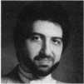

Keynotes

December 1999

VISA

/?,ATM ; DIBIT

CARD



*£L?sm*>*

Diners Club International‘

Accept Credit Cards  
and Increase Sales and Profits  
by 30% - 50%

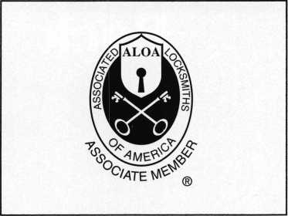

There are three reasons why people don't accept credit cards:

Through Association Benefits **^** 1. Too expensive.

These Concerns Are Eliminated 2. The paperwork hassle.

3. Inability to qualify.

Here’s how it works:

* Simply swipe or enter the credit card #.
* Enter amount of sale. Xo Hassle - Easy Qualifying
* Approval within seconds.
* Funds wired electronically into your local checking account within 48 hours.

&ecei

Because of your association membership, nearly 100% of all retail and home based applicants

will be approved even with past credit problems.

Currently Processing Merchants Please Read ■■■■£

Monthly Lease To Own Set-Up Options

Special Low Discount Rate and Transaction Fee: 1.59% + 20<t

Plus Monthly Statement/Customer Service Fee: $10

Package A: $29.95 Terminal

Package B: $39.95 Terminal & Printer In One

Deluxe Package C: $49.95 Portable Terminal/Printer/Pin Pad  
Debit acess fee Ability to Accept Visa/MC “Check Cards”

$ 10/mo. & ATMQu-dsataFLAT 25?

Totally Eliminating the 1.59 % Rate  
(All lease terms 48 months • Monthly minimum $25)

] I authorize Universal’s sales office to print and deposit a check  
in the amount of $49 (normally $125) for my application fee which

covers initial materials, application processing, equipment warranty,

shipping & handling, programming, installation and training.

* Fill out a check, tape here above mini form and then fax.

Fax Express Mini Form Now To **1 -800-439-7773**

You

The

,'®*or/oS,“<®<S.«Wrate

•Sfefsjv,

**** Hired

to

i-f,

1

Company Name. Contact Name _

Address. City

State-

Zip.

Phone

Best Time

Signature

New Account Set-up Options (Check)

Package A □

Package B □

Deluxe Package C I—I

Free Pin Pad Program For Currently Processing Merchants □

A subsidiary of Universal Savings Bank, FA.

Marketing Office *1-800-836-4295*

Universal Payment Processing Provides **24** Hour Live Customer Service.



ft

**Back**

Page

i' '*4 4 iY.':

’ ■ ■ # •

* 44l *Keynotes*

**December 1999**

**A new year... a new look!**

**We’ll be trying something a little different in February,**

**so keep an eye out for Keynotes’ new format. This is merely**

**a temporary alteration, so we can examine new methods**

**of presenting quality information regarding ALOA and**

**the locksmith industry. Watch for it soon!**

(□extend my subscription to Locksmith Ledger

International

Please

**The TetHfikal Nej**

**nfcfcir the Security Professional**

OrELNING  
A WORLD OP  
OrrORTLlNITIC.5

□ 3 YEARS (includes 36 issues, 3 FREE Annual Directory* issues)

USA $90.00

J 2 YEARS (includes 24 issues, 2 FREE Annual Directory* issues)

USA $64.00 Canada $93.00 International (air) $185.00 International (surface) $119.00

11 YEAR (includes 12 issues, 1 FREE Annual Directory* issue)

USA $41.00 Canada $52.00 International (air) $100.00 International (surface) $65.00

‘Comprehensive guide to industry manufacturers, distributors, products and services.

**CARD INVALID UNLESS COMPLETE DATA IS GIVEN**

You must indicate your locksmithing affiliation below:

1. Are you a locksmith or an individual involved in locksmithing? Qyes Qno
2. Your position is: QOwner/Pres. Q3 Employee Q6 Student Q9 Other (specify)

3 Business classification (check one only): a Q Locksmith Shop b QHardware c Q Wholesaler/Distributor d Q Manufacturer eQ Security or Maintenance

1Q Consultant 3 □ Industrial sQ Government

2 Q Commercial 4 QInstitutional 6 Q Police

g Q Architect/Specifier z Q Other (specify)

4. Are you involved in purchasing or influencing the purchase of locksmith products?

□yes Qno

Name:.

Company:. Address: _

City:.

. State:.

.Zip:.

Phone:

.Fax:

Payment (US FUNDS ONLY): QlVIoney order □Charge Card □Check#:

Complete For Charge Orders Only: QVISA □ Master Card □American Express

Account # :Exp. Date:

Signature: —

IM9

►end payment to: Locksmith Publishing Corp. • 850BusseHwy. • Park Ridge, IL 60068 • Phone:(847)692-5940 • Fax (847) 692-4604 • Website: [www.lpc.simon-net.com](http://www.lpc.simon-net.com)

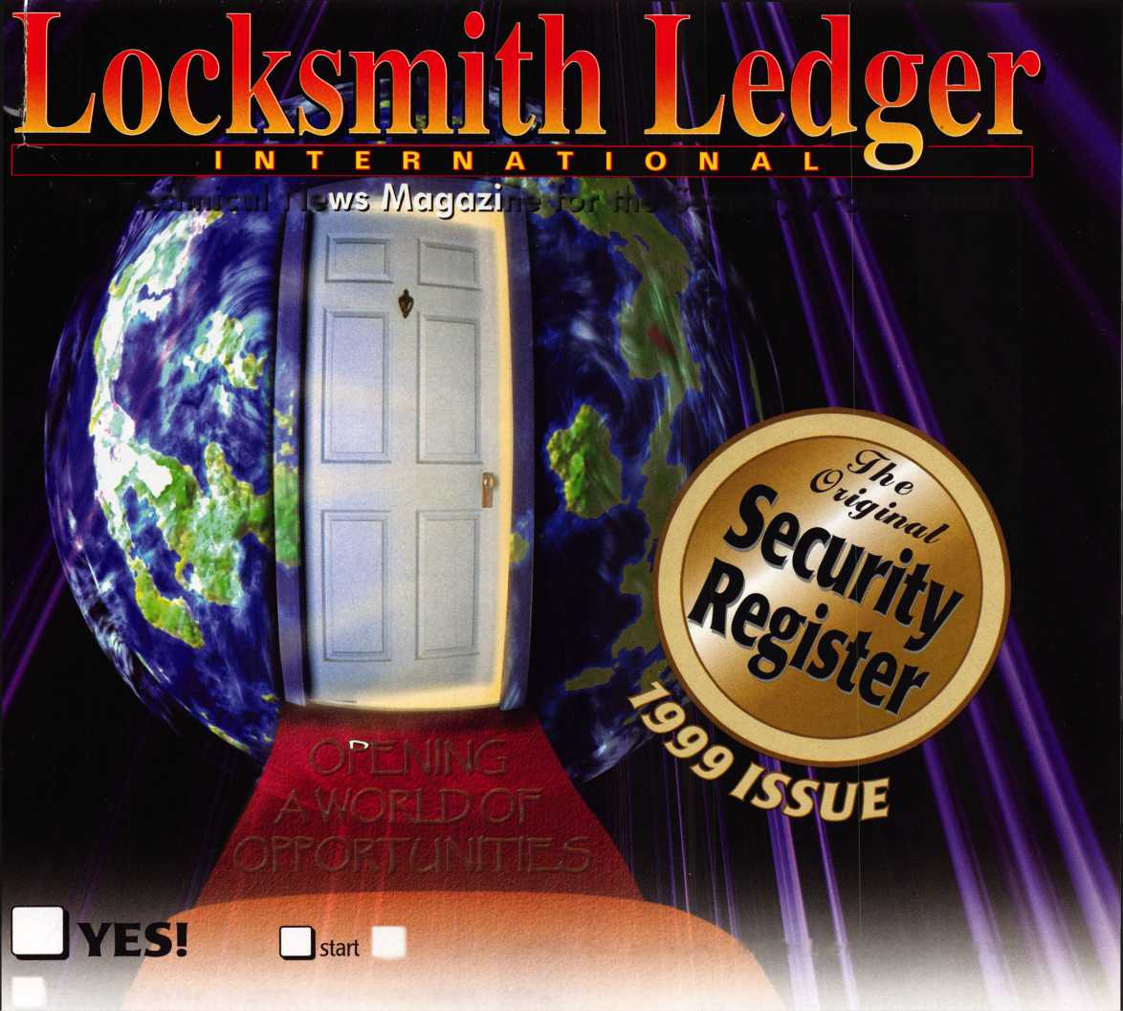

HID CORPORATION

eProx™

Lock technology  
available from:

Alarm Lock

**ISOProx® II**

**opens**

Introducing the ePROX™Lock Module ( only from HID.

Now the security and reliability of proximity access is available in standard electronic locks. It’s battery-powered for stand-alone applications, and, using the same HID card or key fob, it can

Cypress J Computer I Systems

! Ilco Unican

tLocknetics

easily augment an  
existing on-line access  
control system.With  
HID battery-powered  
proximity, the one card

solution becomes a simple and  
economical reality. The ePROX™  
Lock Module from HID. Proximity  
access has finally arrived at your door.

[www.hidcorp.com](http://www.hidcorp.com)

Copyright 1999 HID Corporation

We identify with your business. #



(8 0 0)

2 3 7

P R 0 X

(7 7 6 9)

HID CORPORATION

